Lab Exercise 2

Terraform AWS Provider and IAM User Setting

Step 1: Create a New Directory: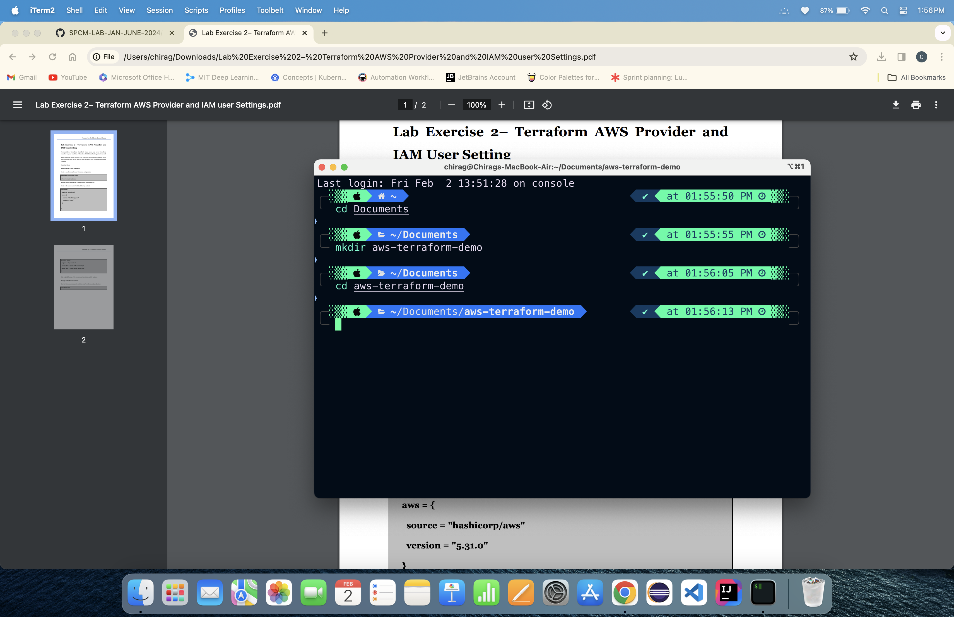

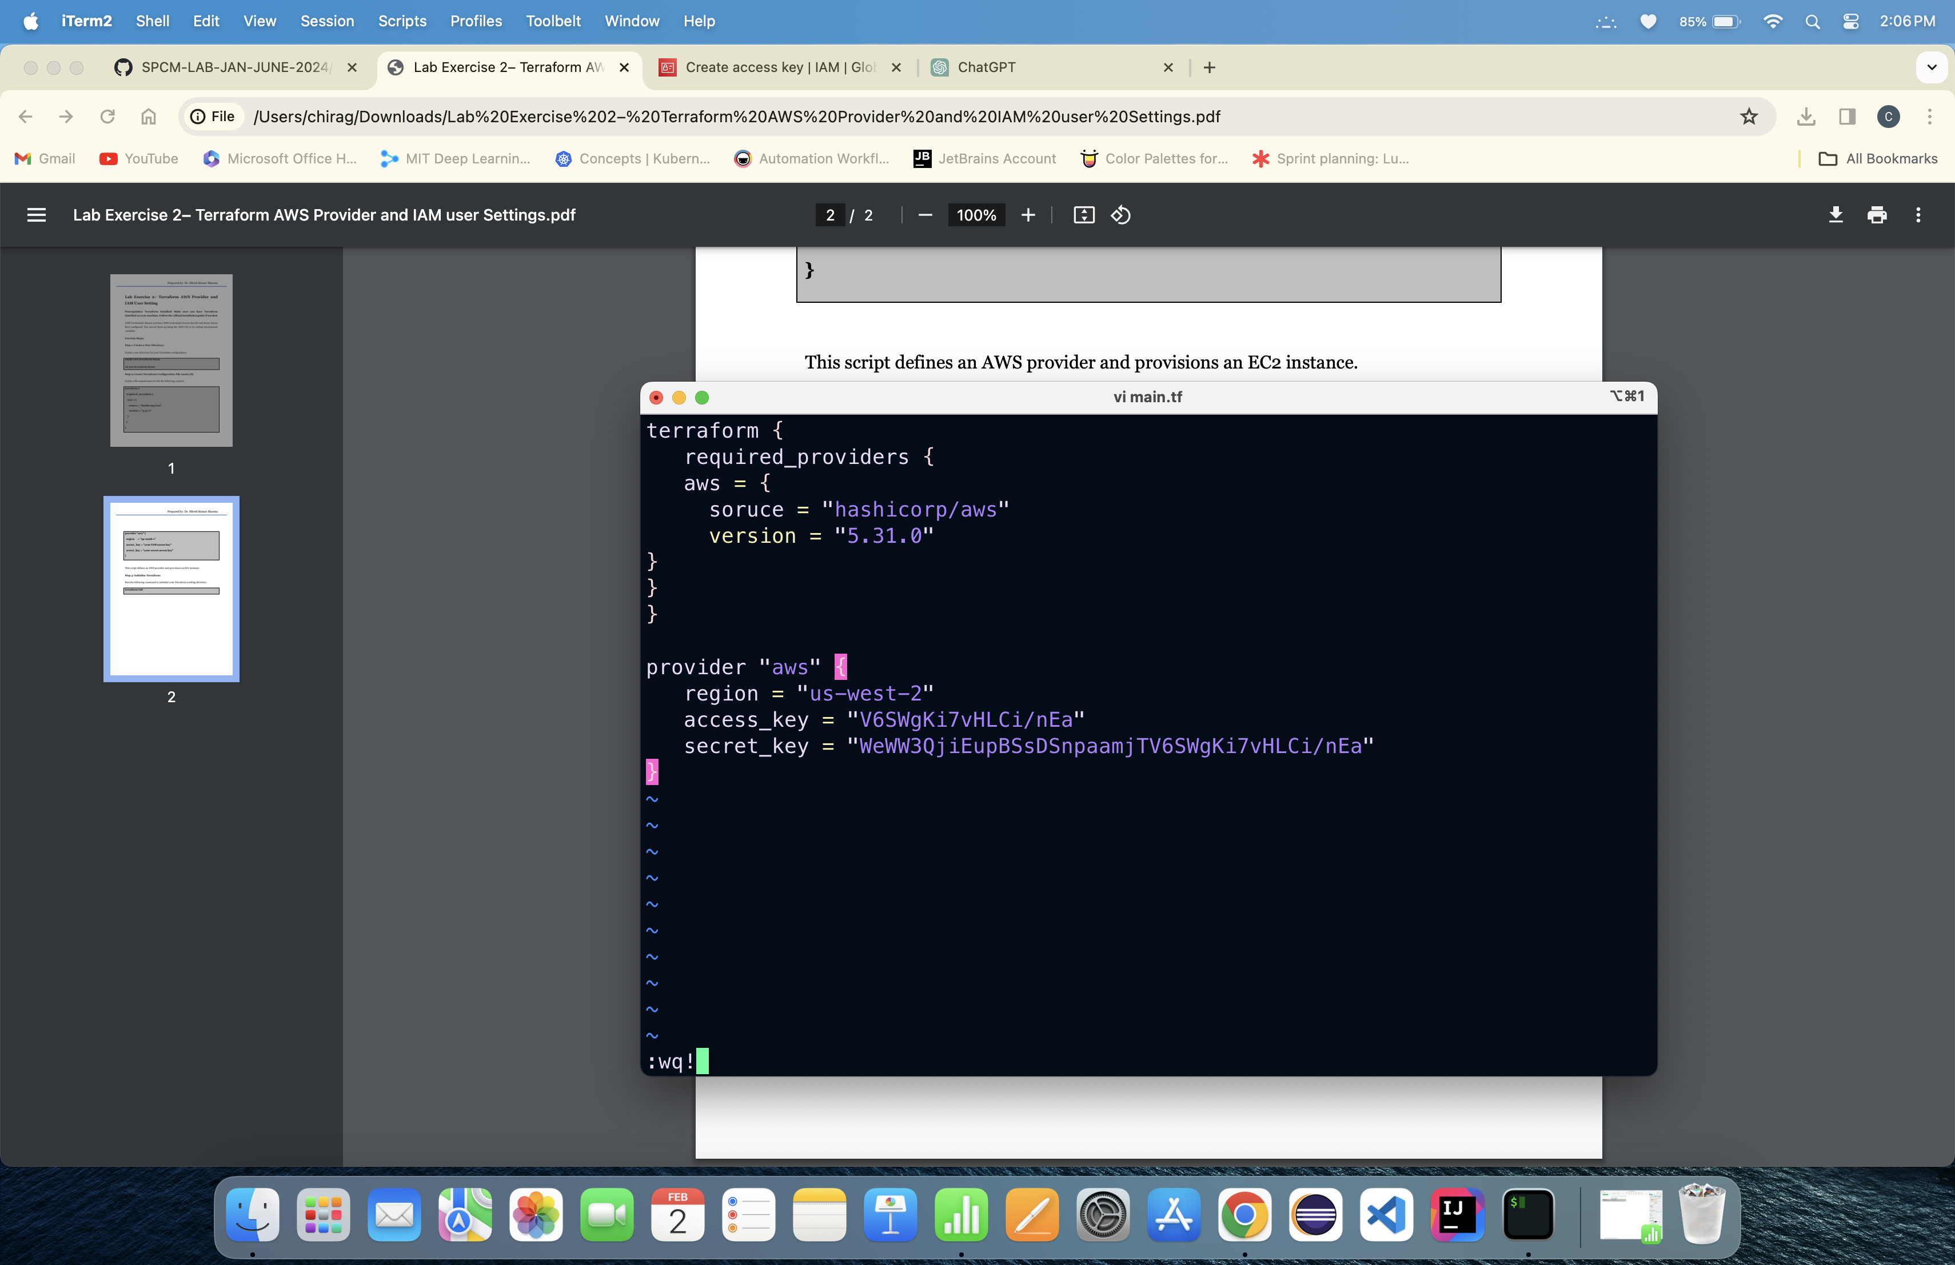

Step 2: Create Terraform Configuration File (main.tf)

Step 3: Initialize Terraform:

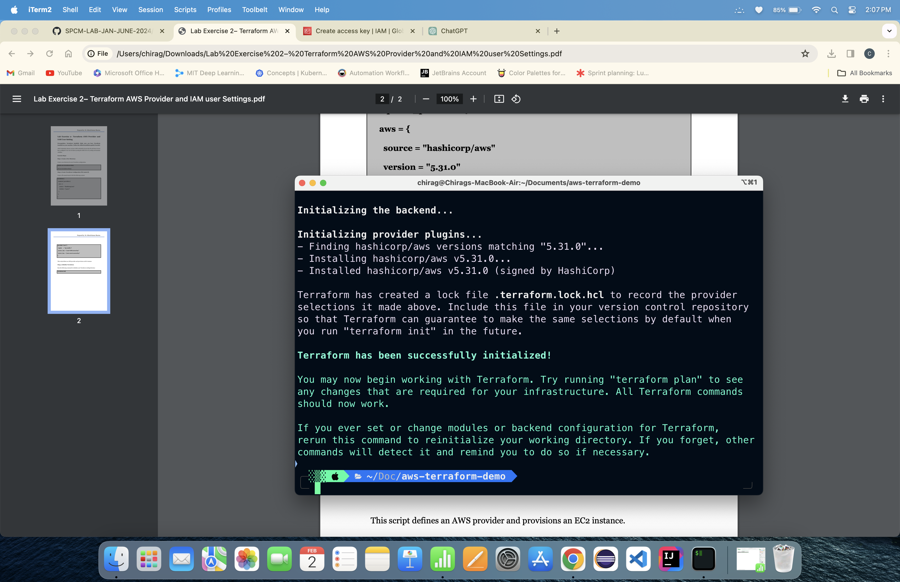

Lab Exercise -3

Provisioning an EC2 Instance on AWS

Step-1 Create a Direct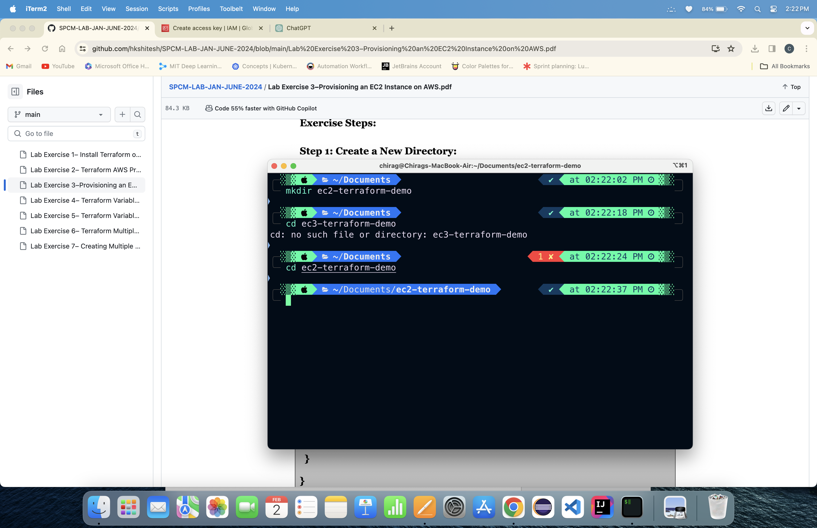ory

Step-2 Create a main.tf File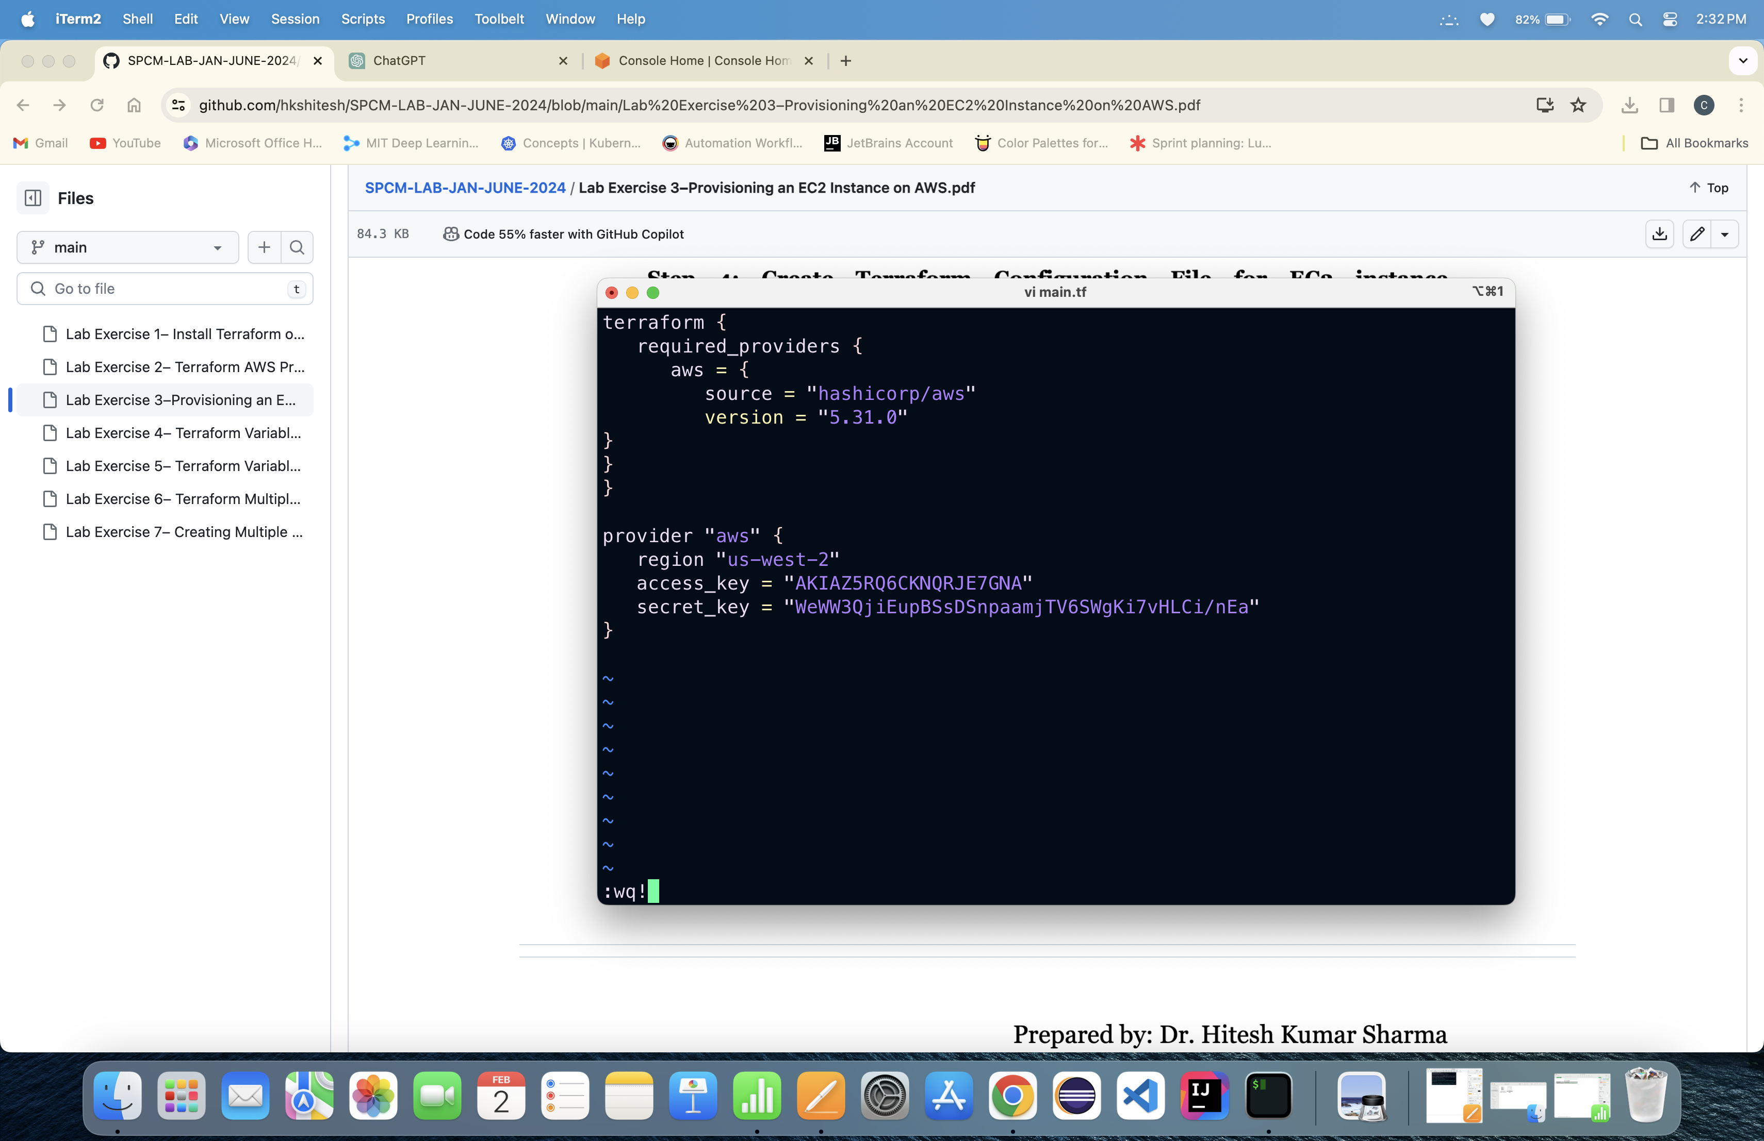

Step-3 Create instance.tf File

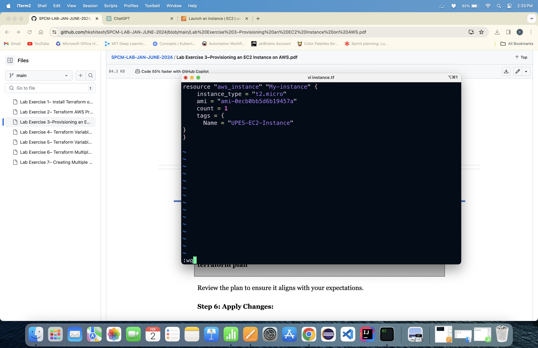

Step-4 Run Terraform init command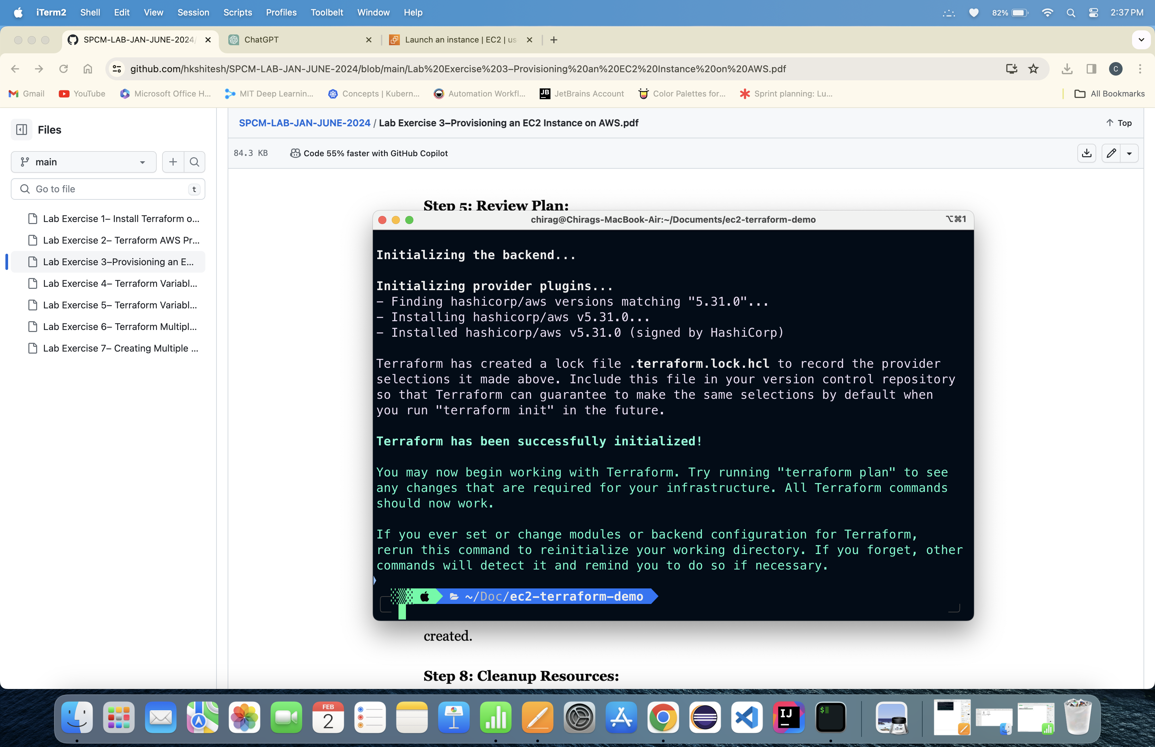

Step-5 Run Terraform Plan command

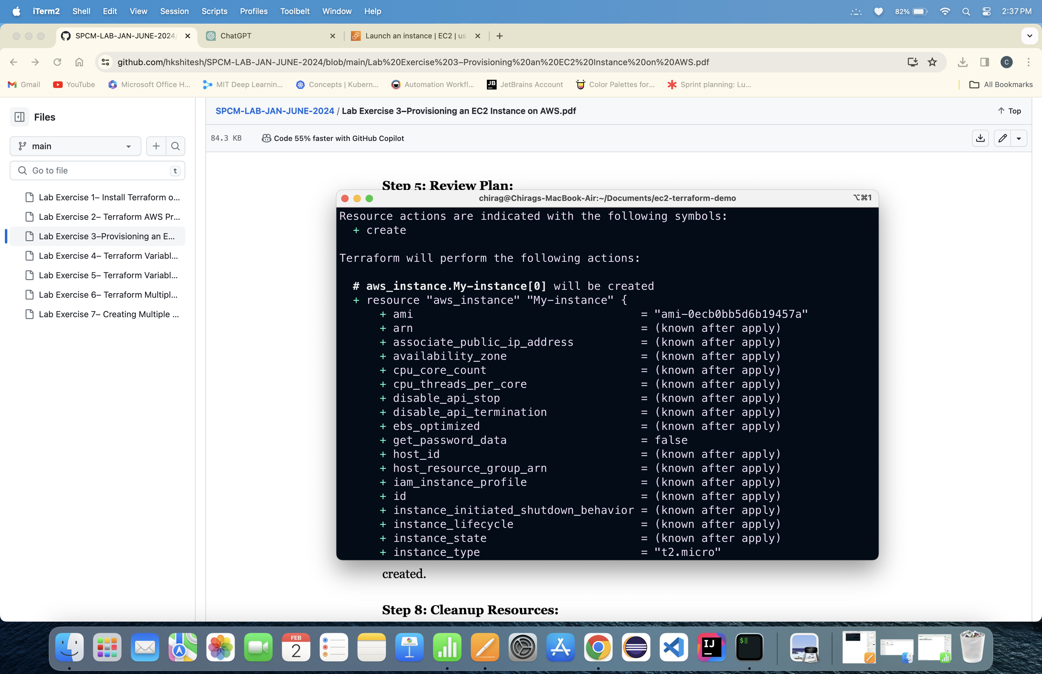

Step-6 Run Terraform Apply command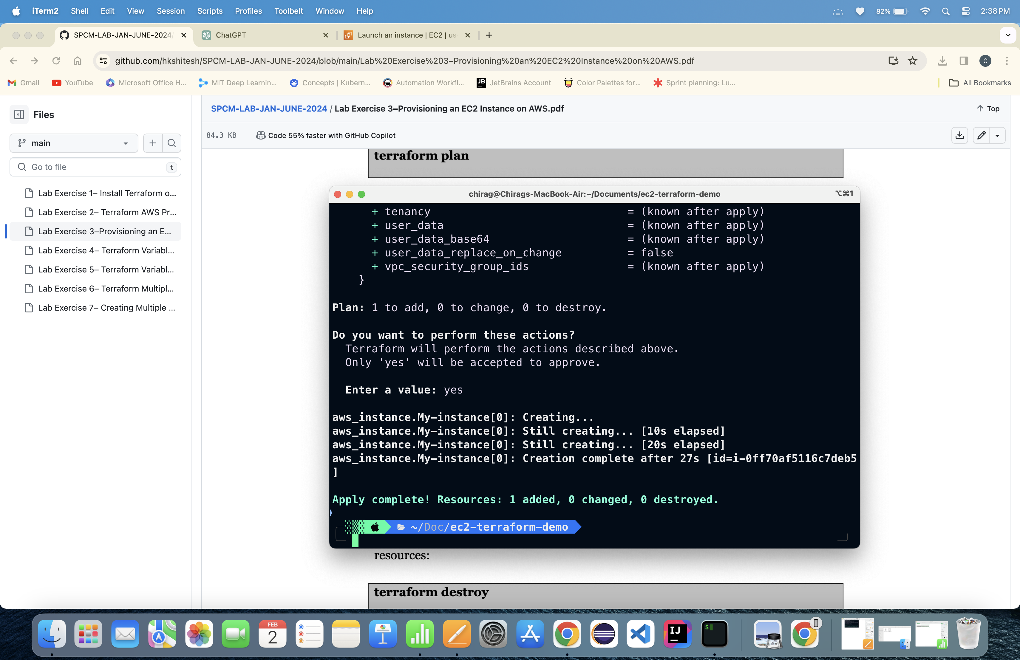

Instance is Created

Step -7 Run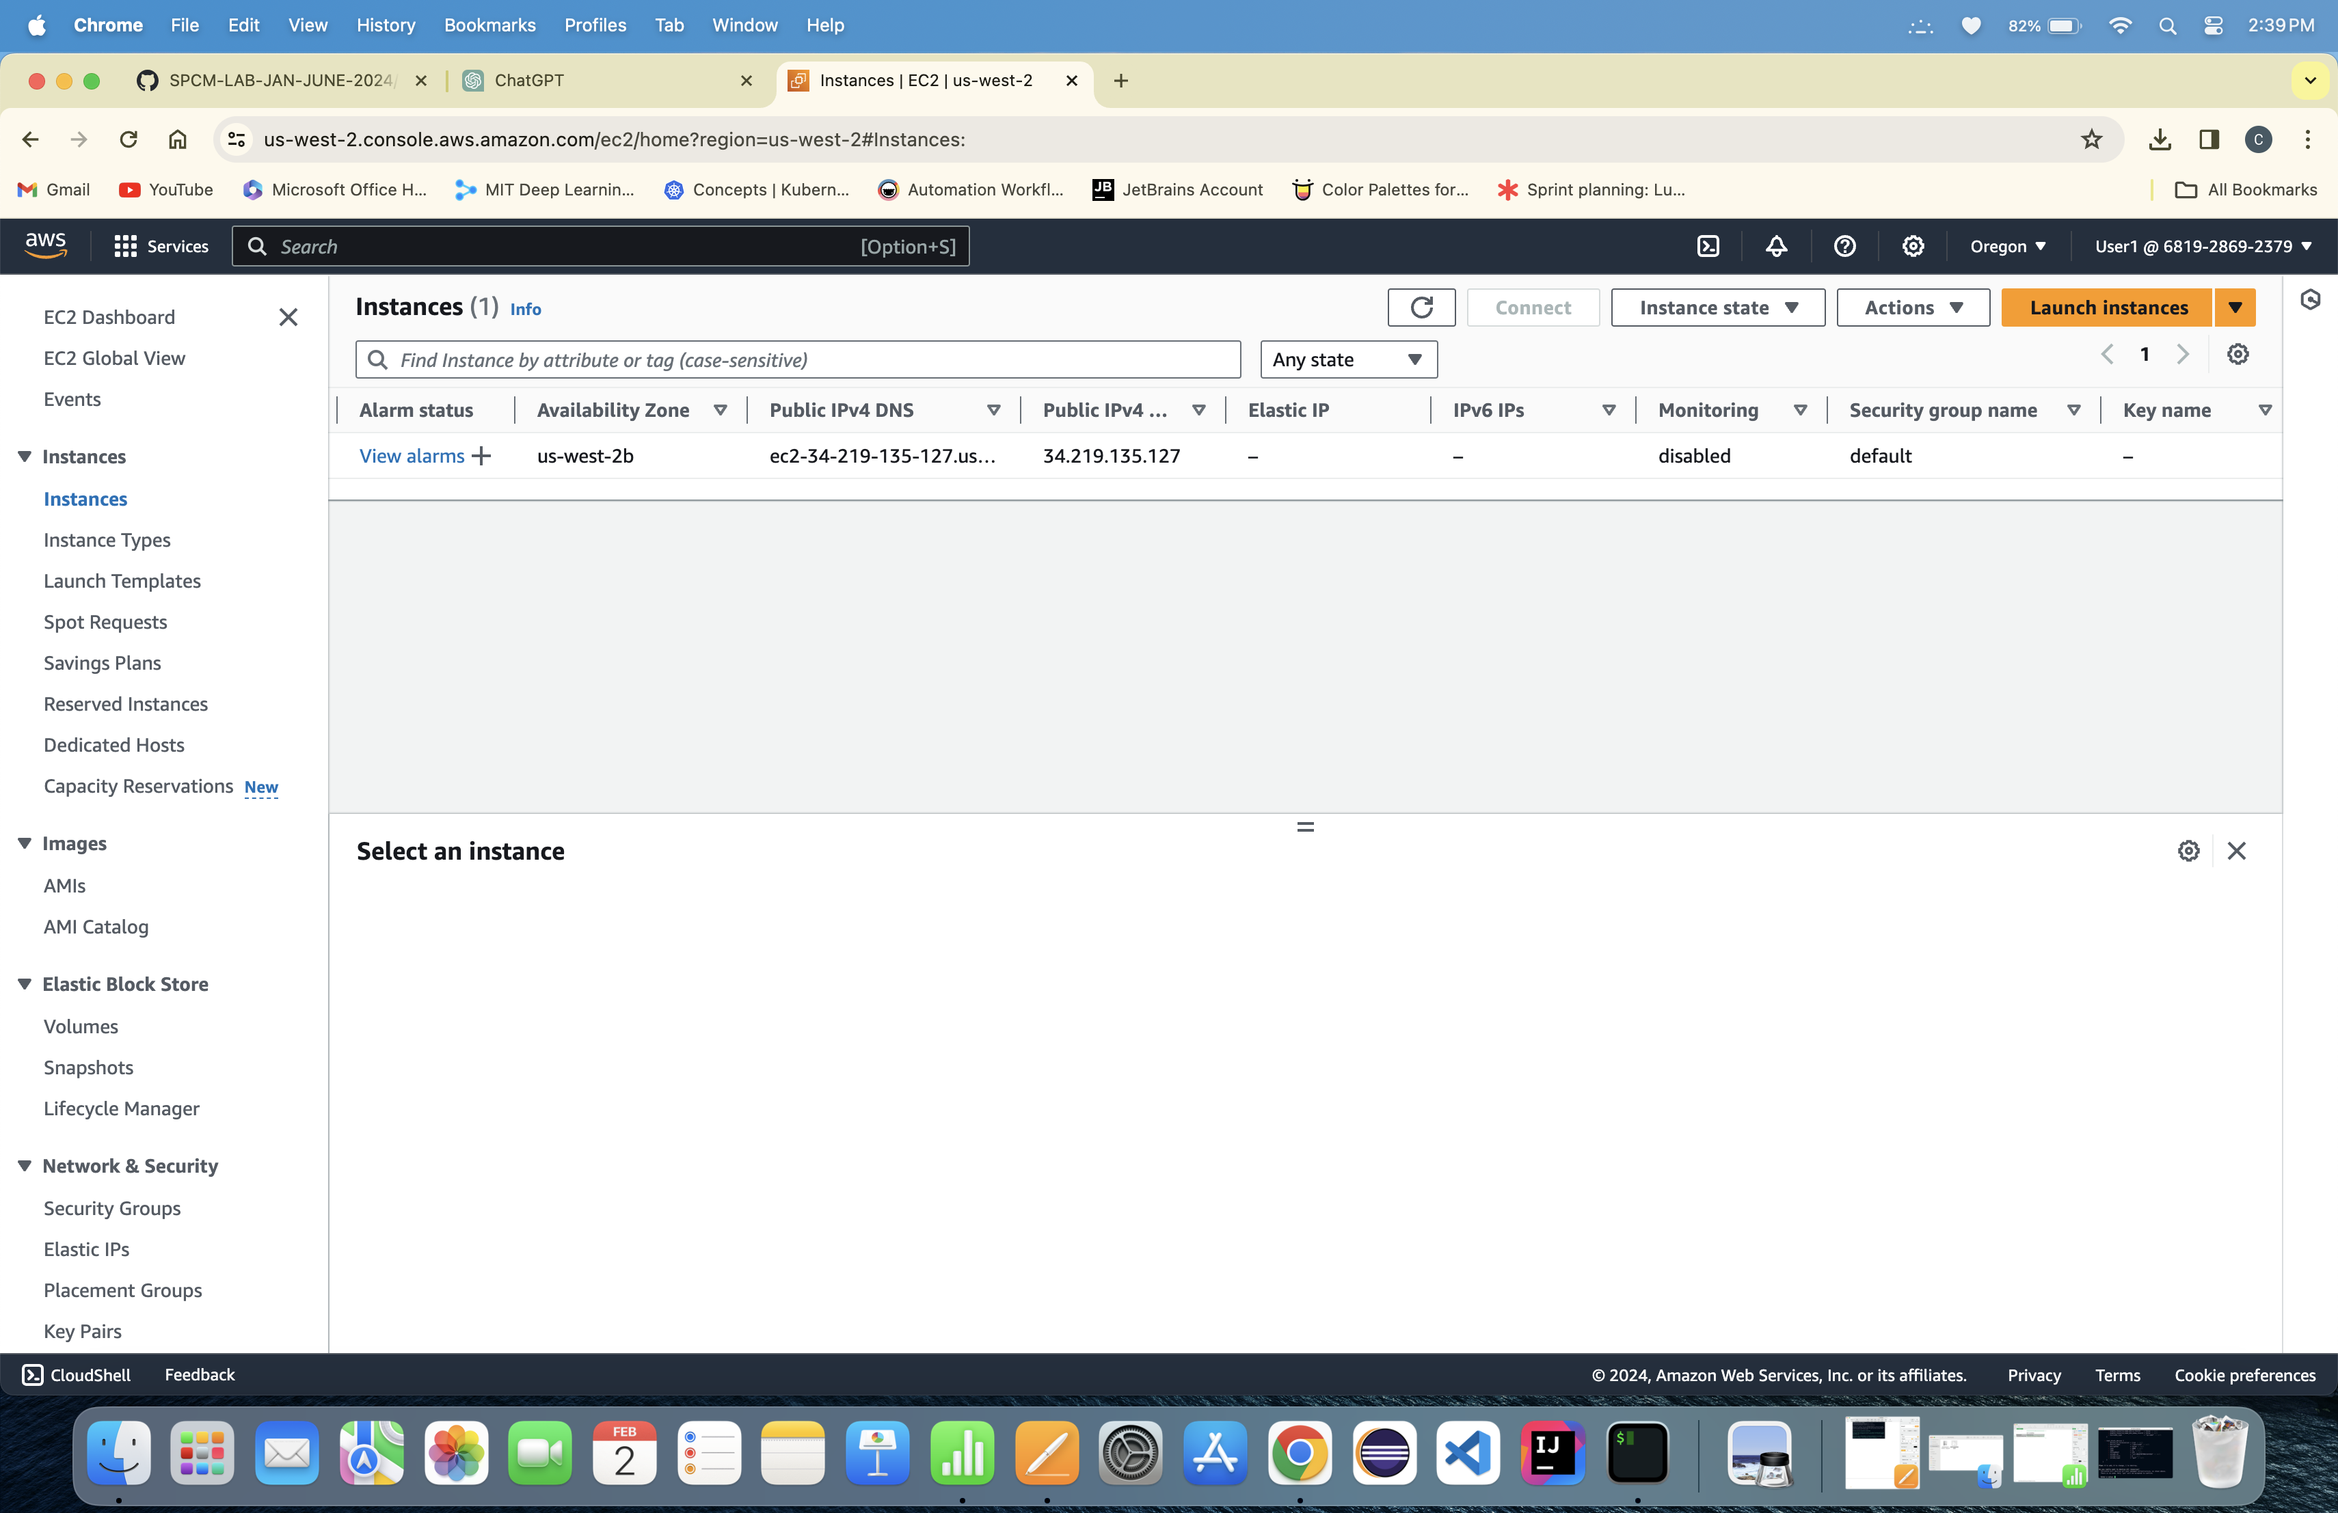 the Terraform Destroy Command

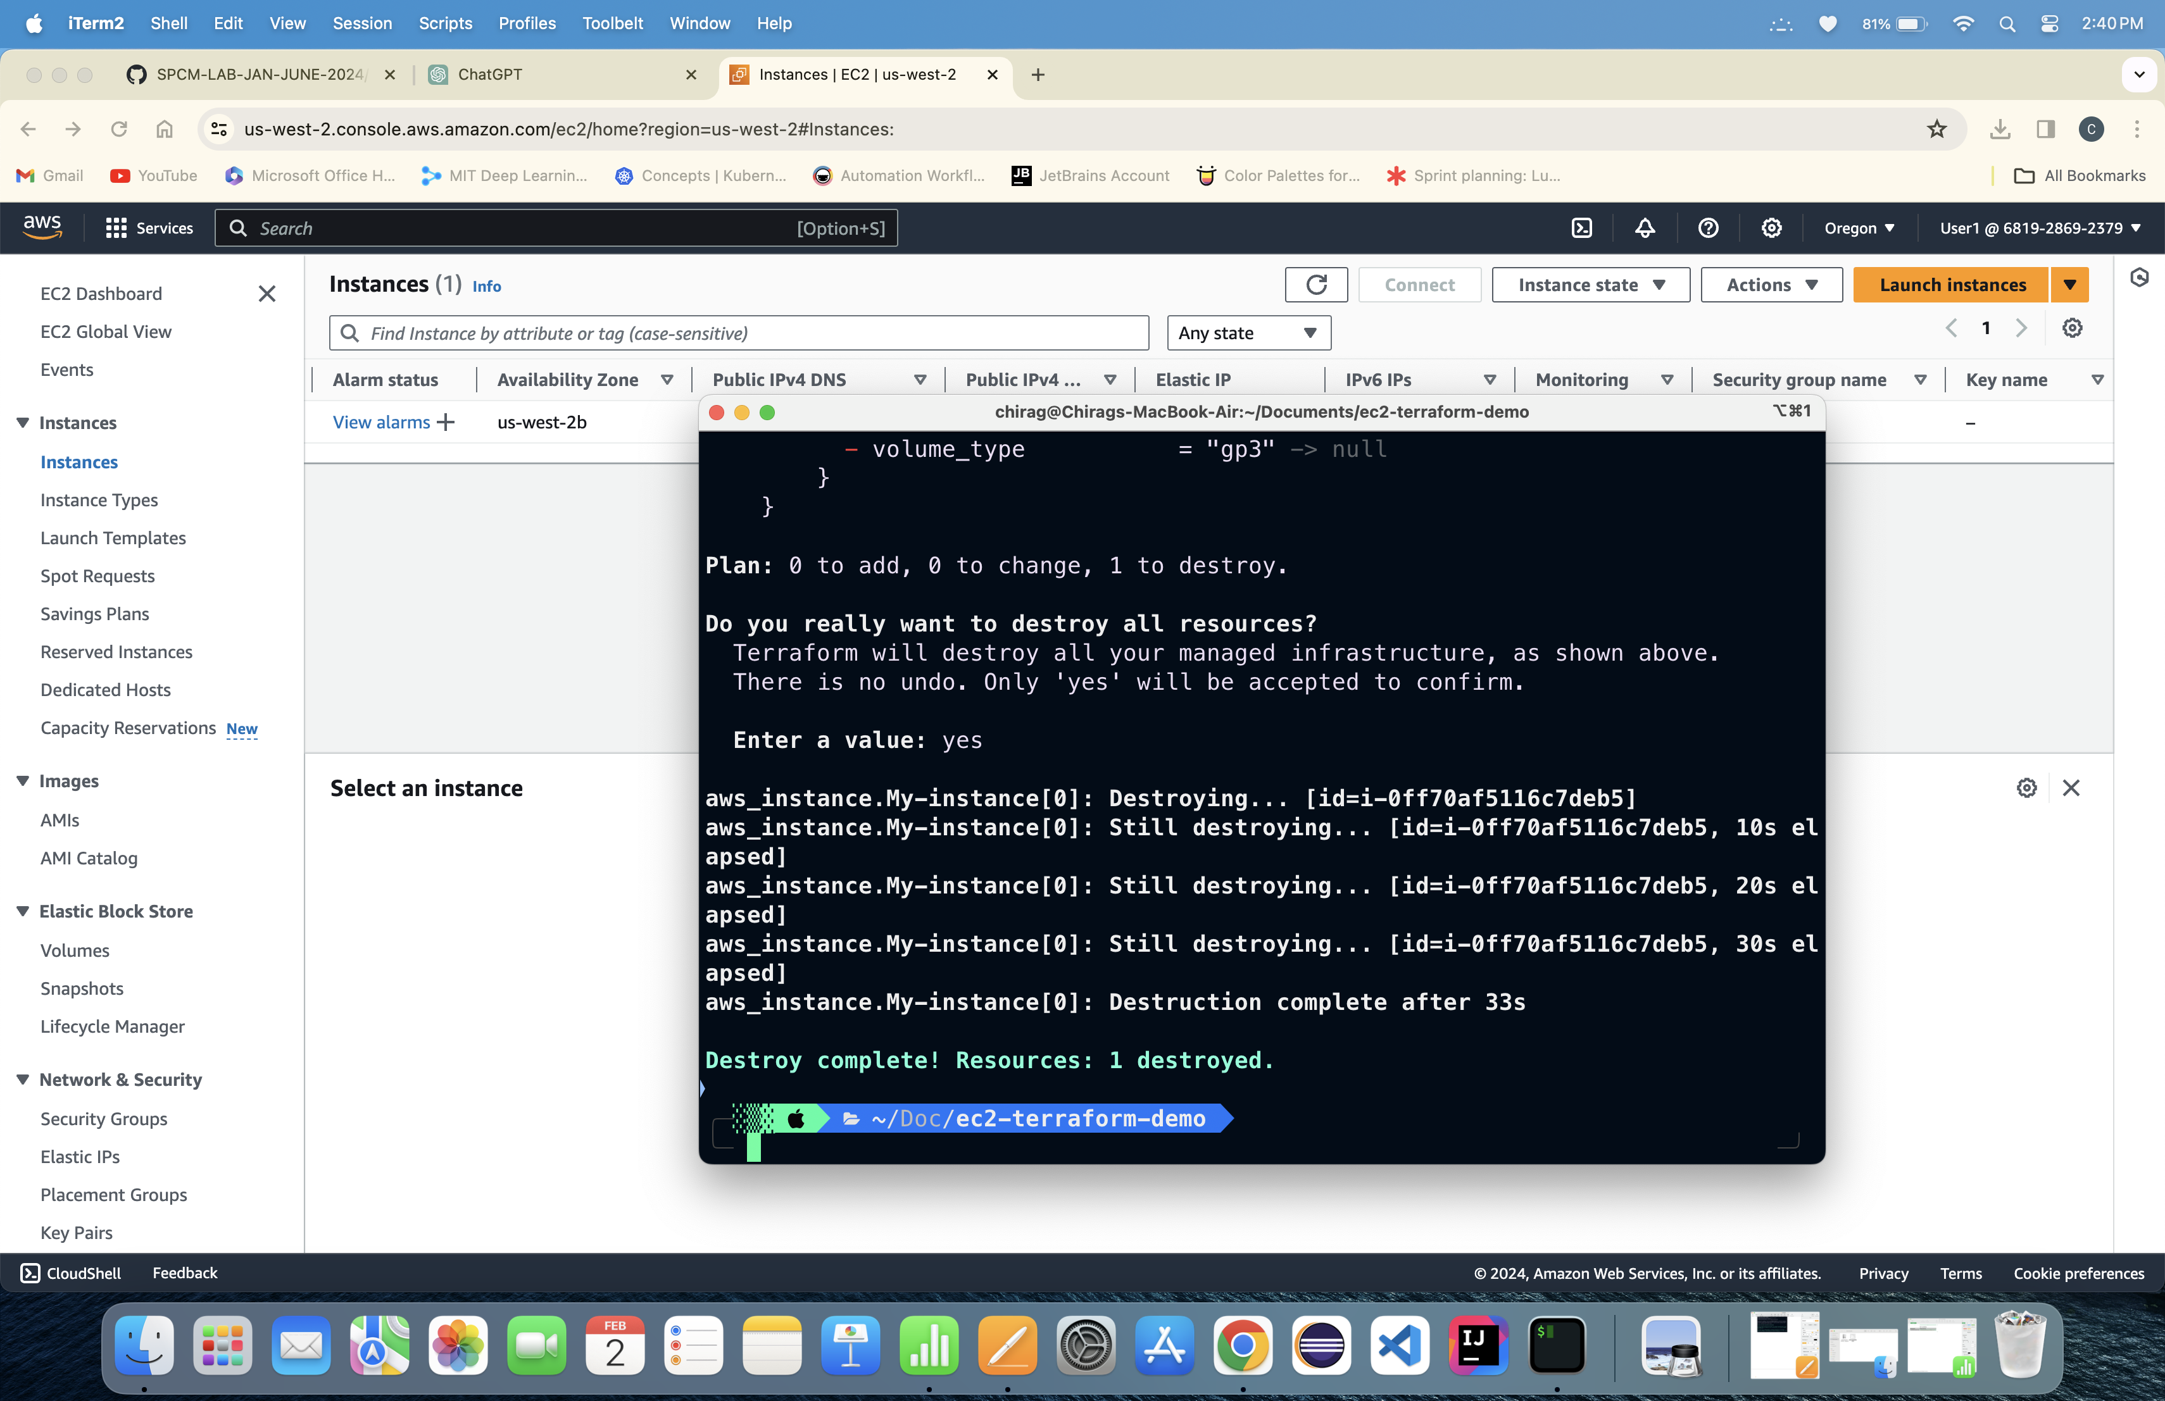

Lab Exercise -4

Terraform Variables

1. Create a Terraform Directory:

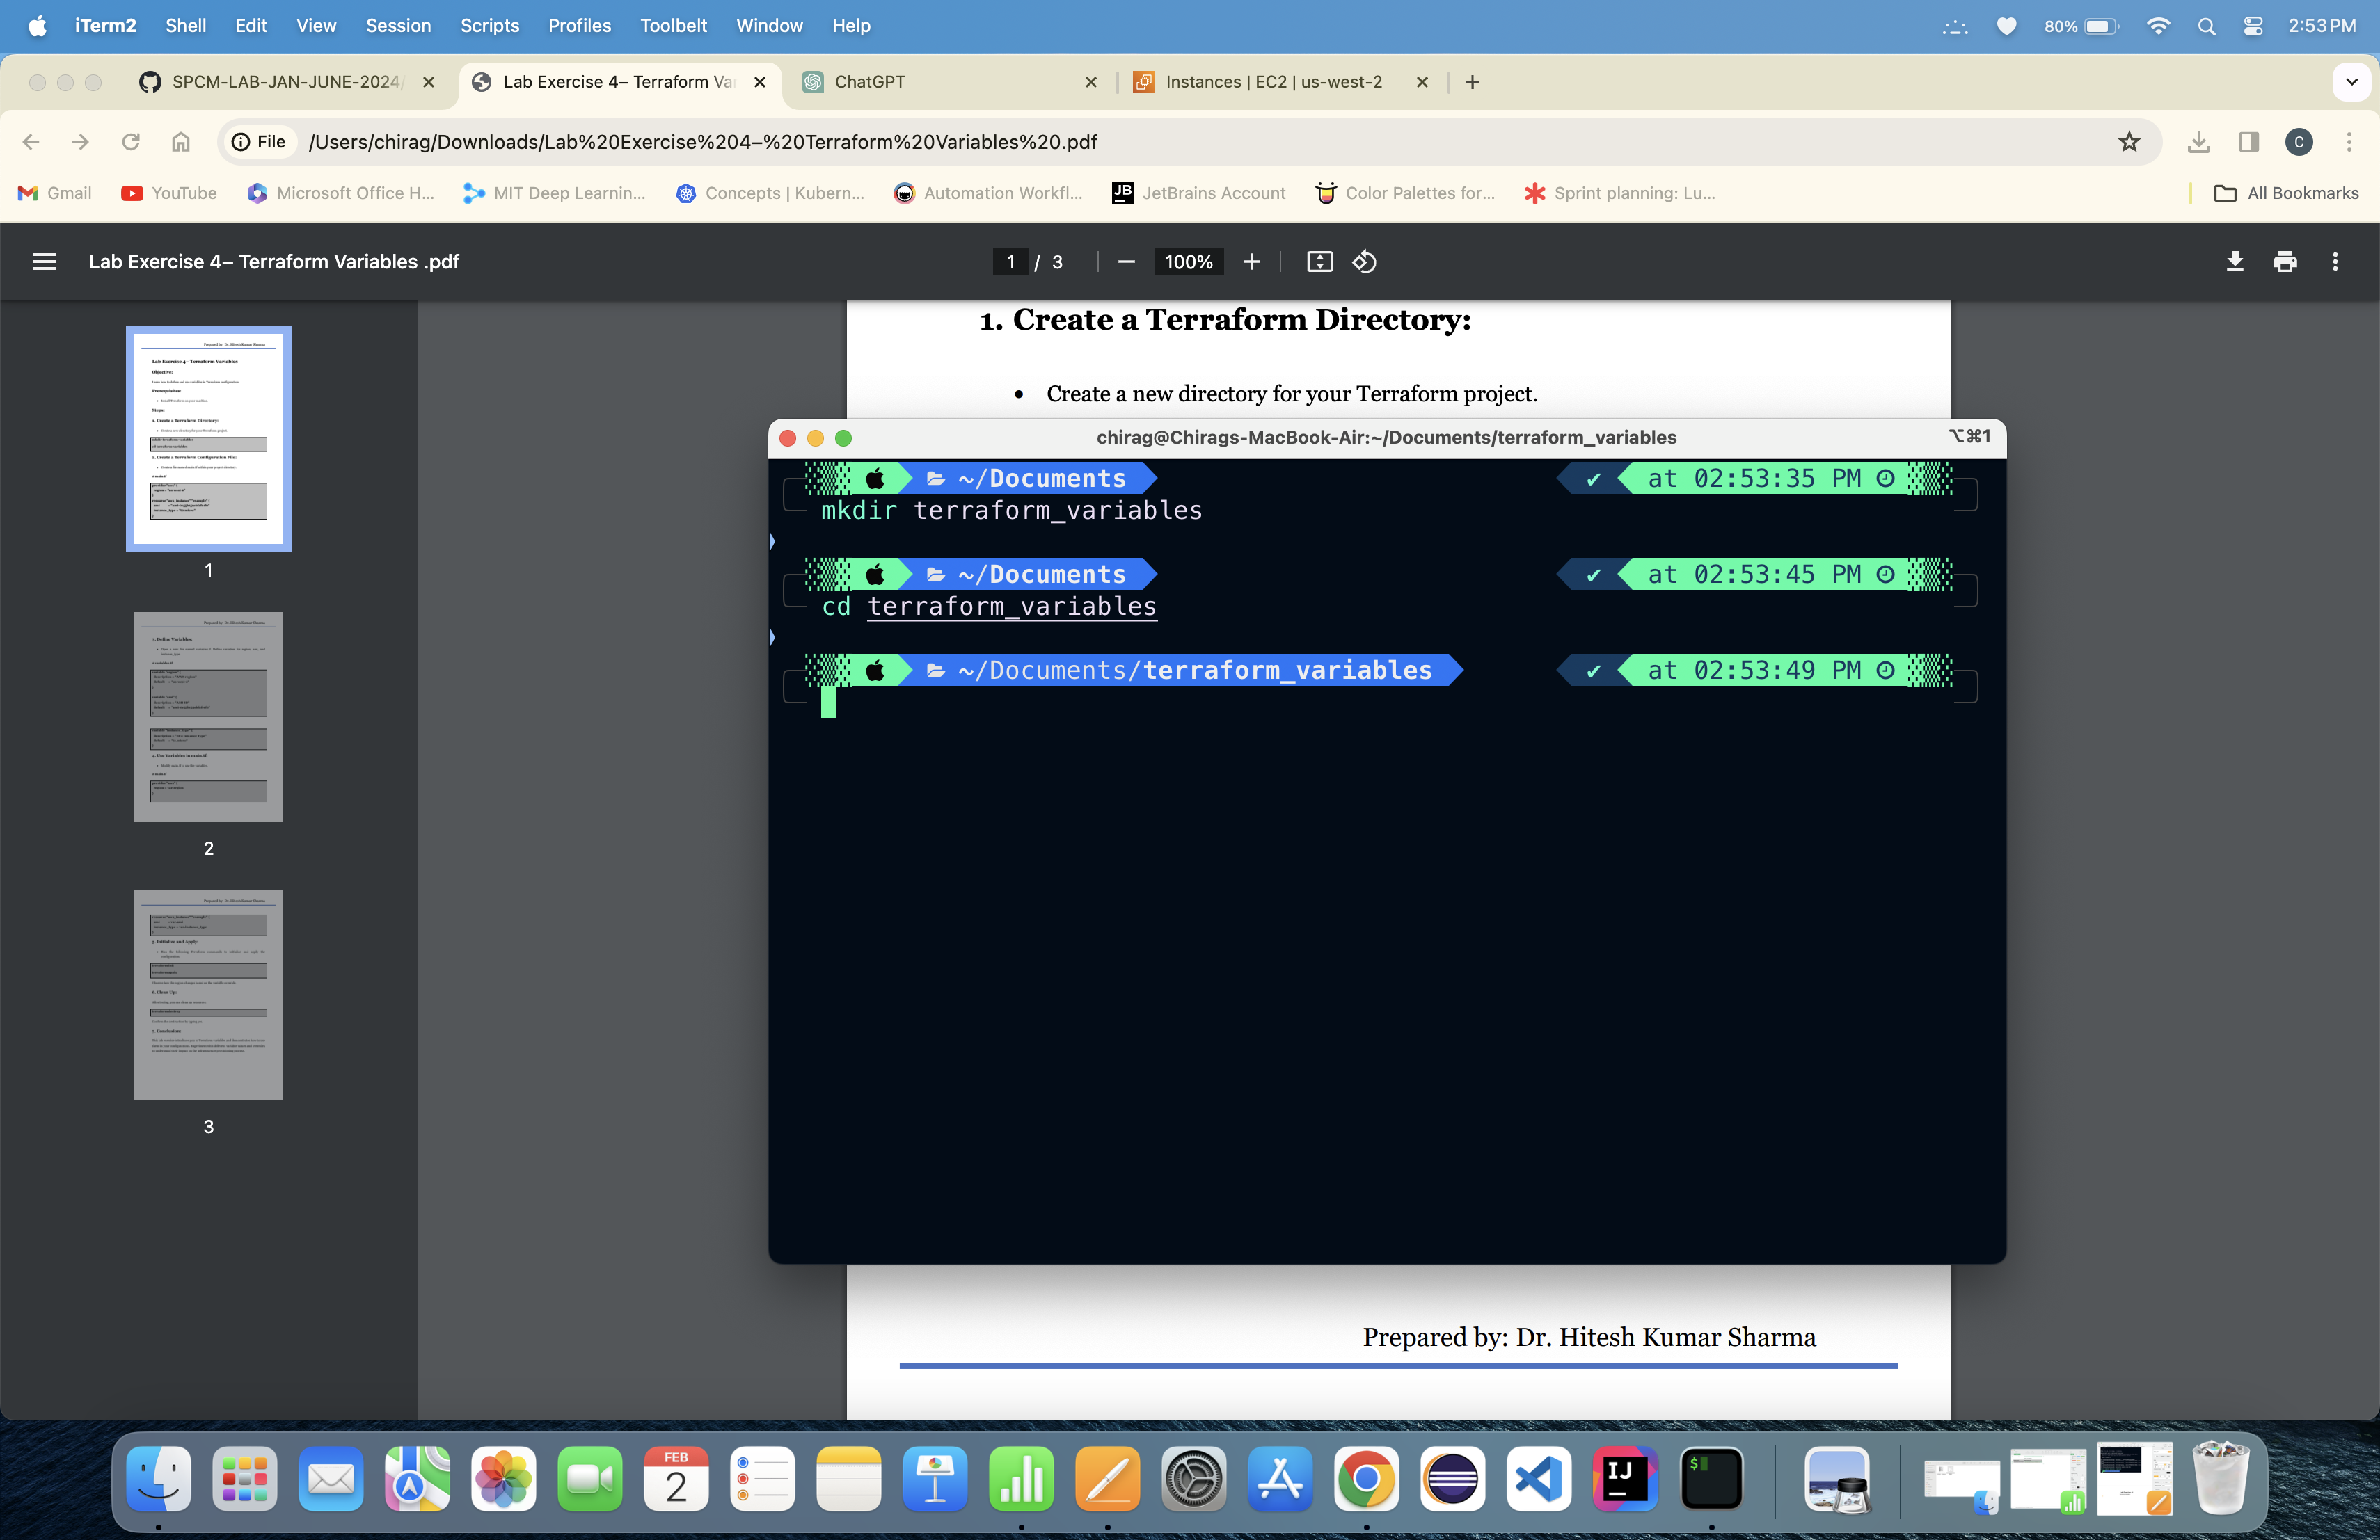

2. Create a Terraform Configuration File:

—> Main.tf without using variables.tf file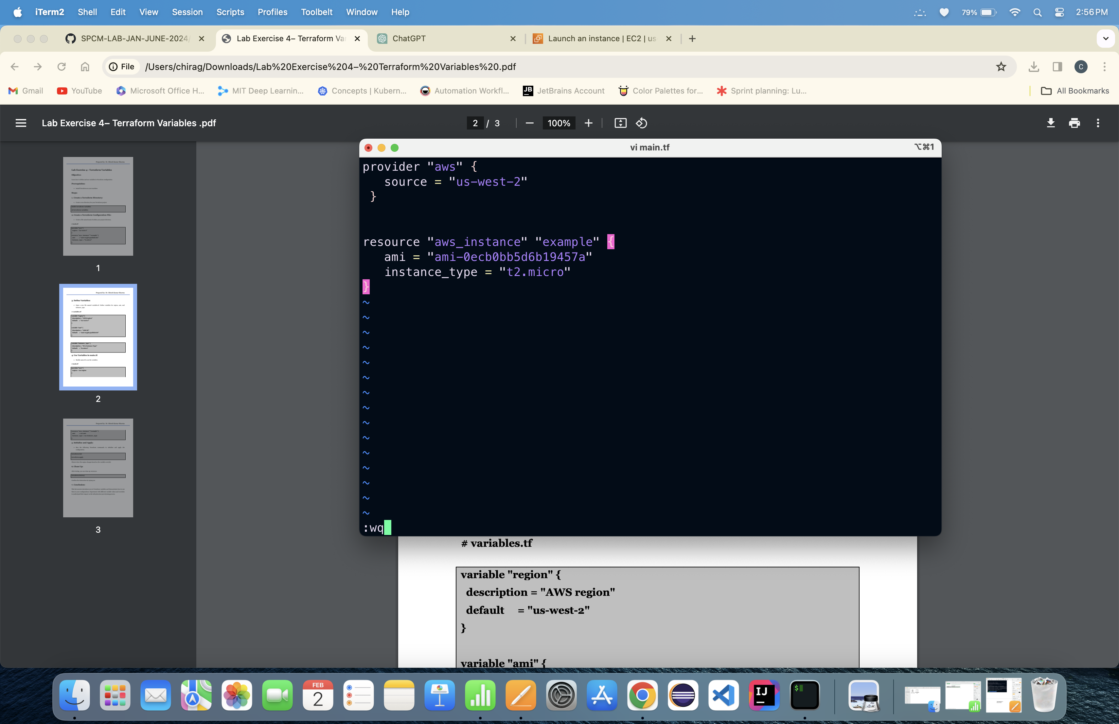

—> Creating a Variable.tf File

—> Using Va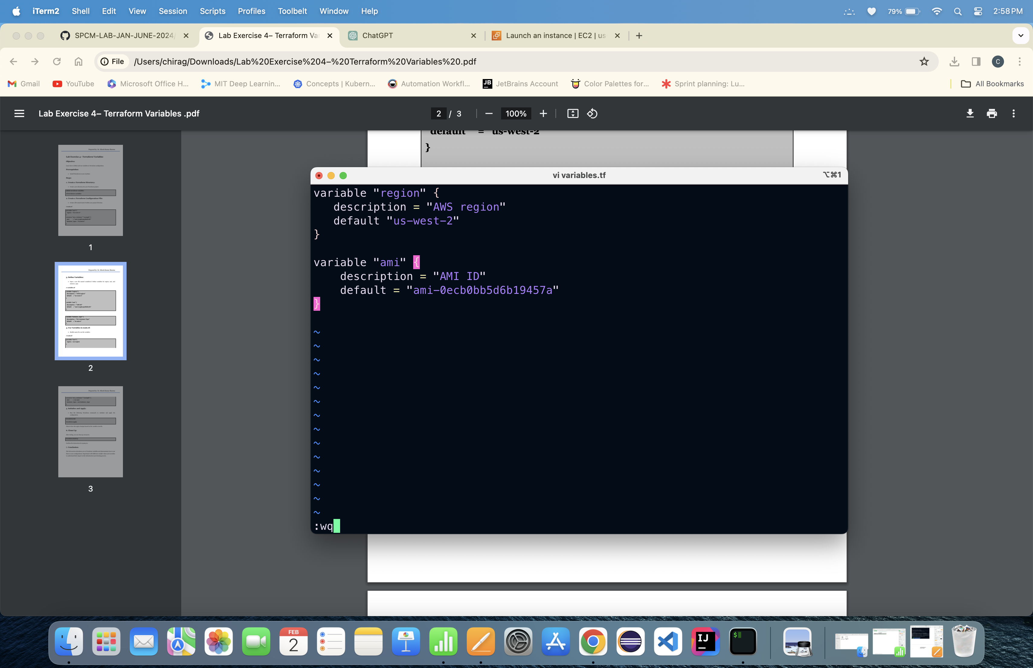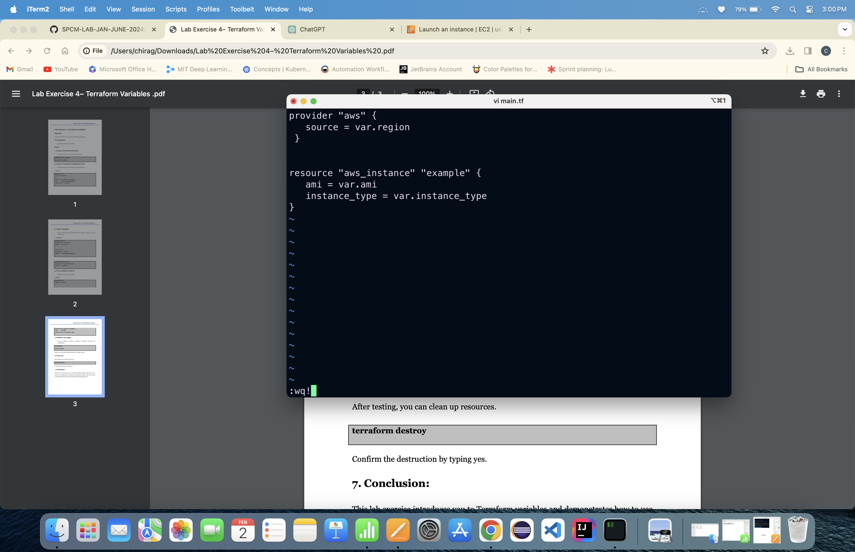riable.tf file and configuring main.tf

3. Running Terraform init command:

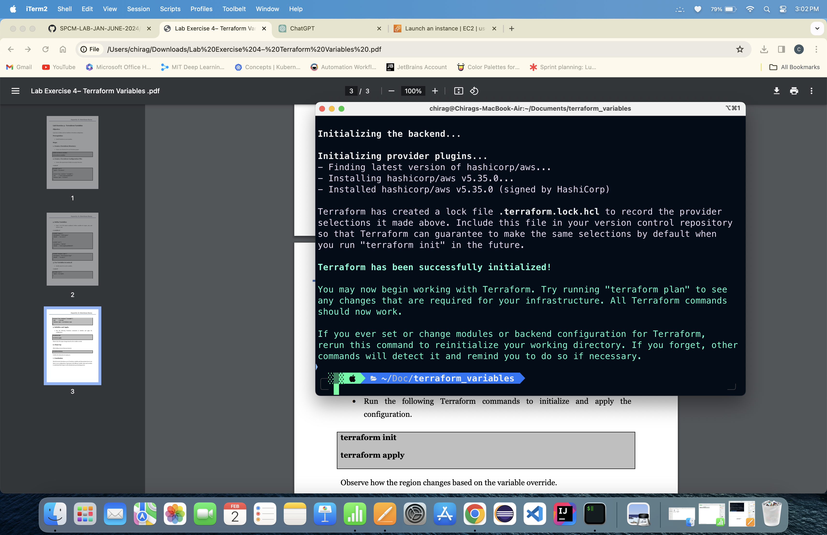

4. Running Terraform Apply command:

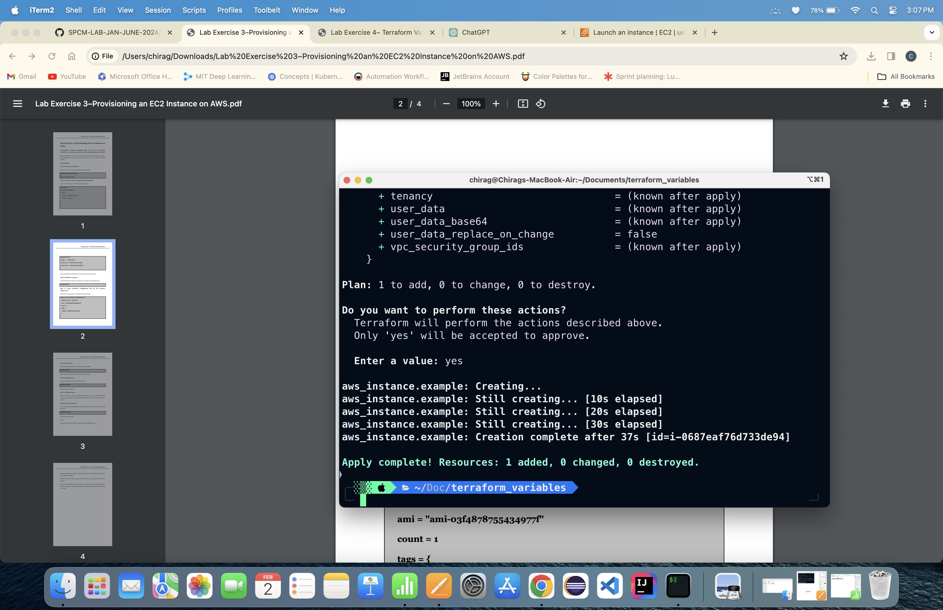

Instance is running: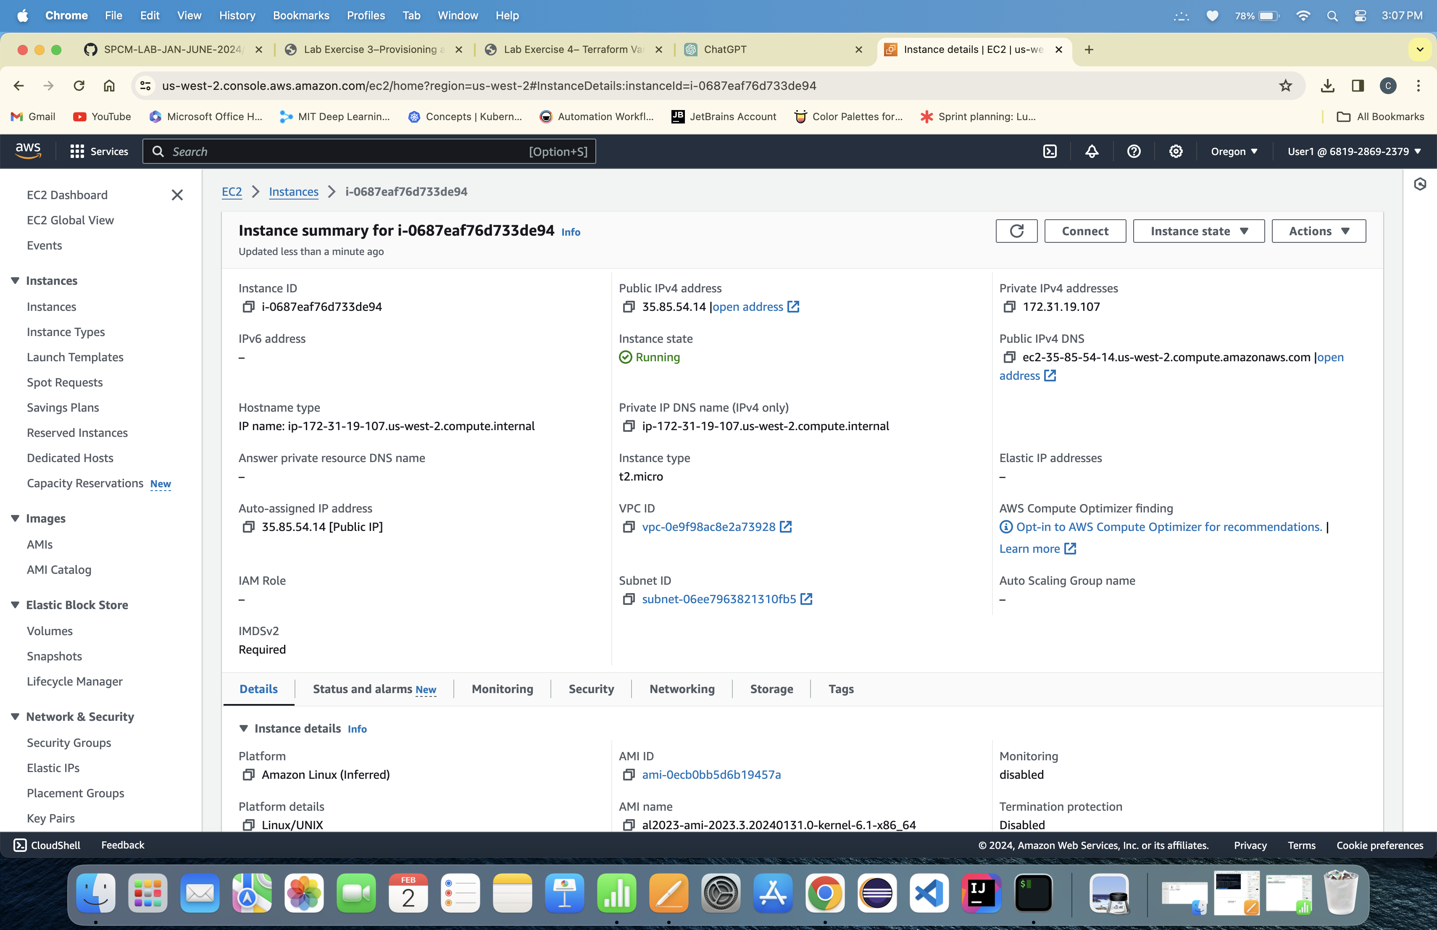

5. Running Terraform D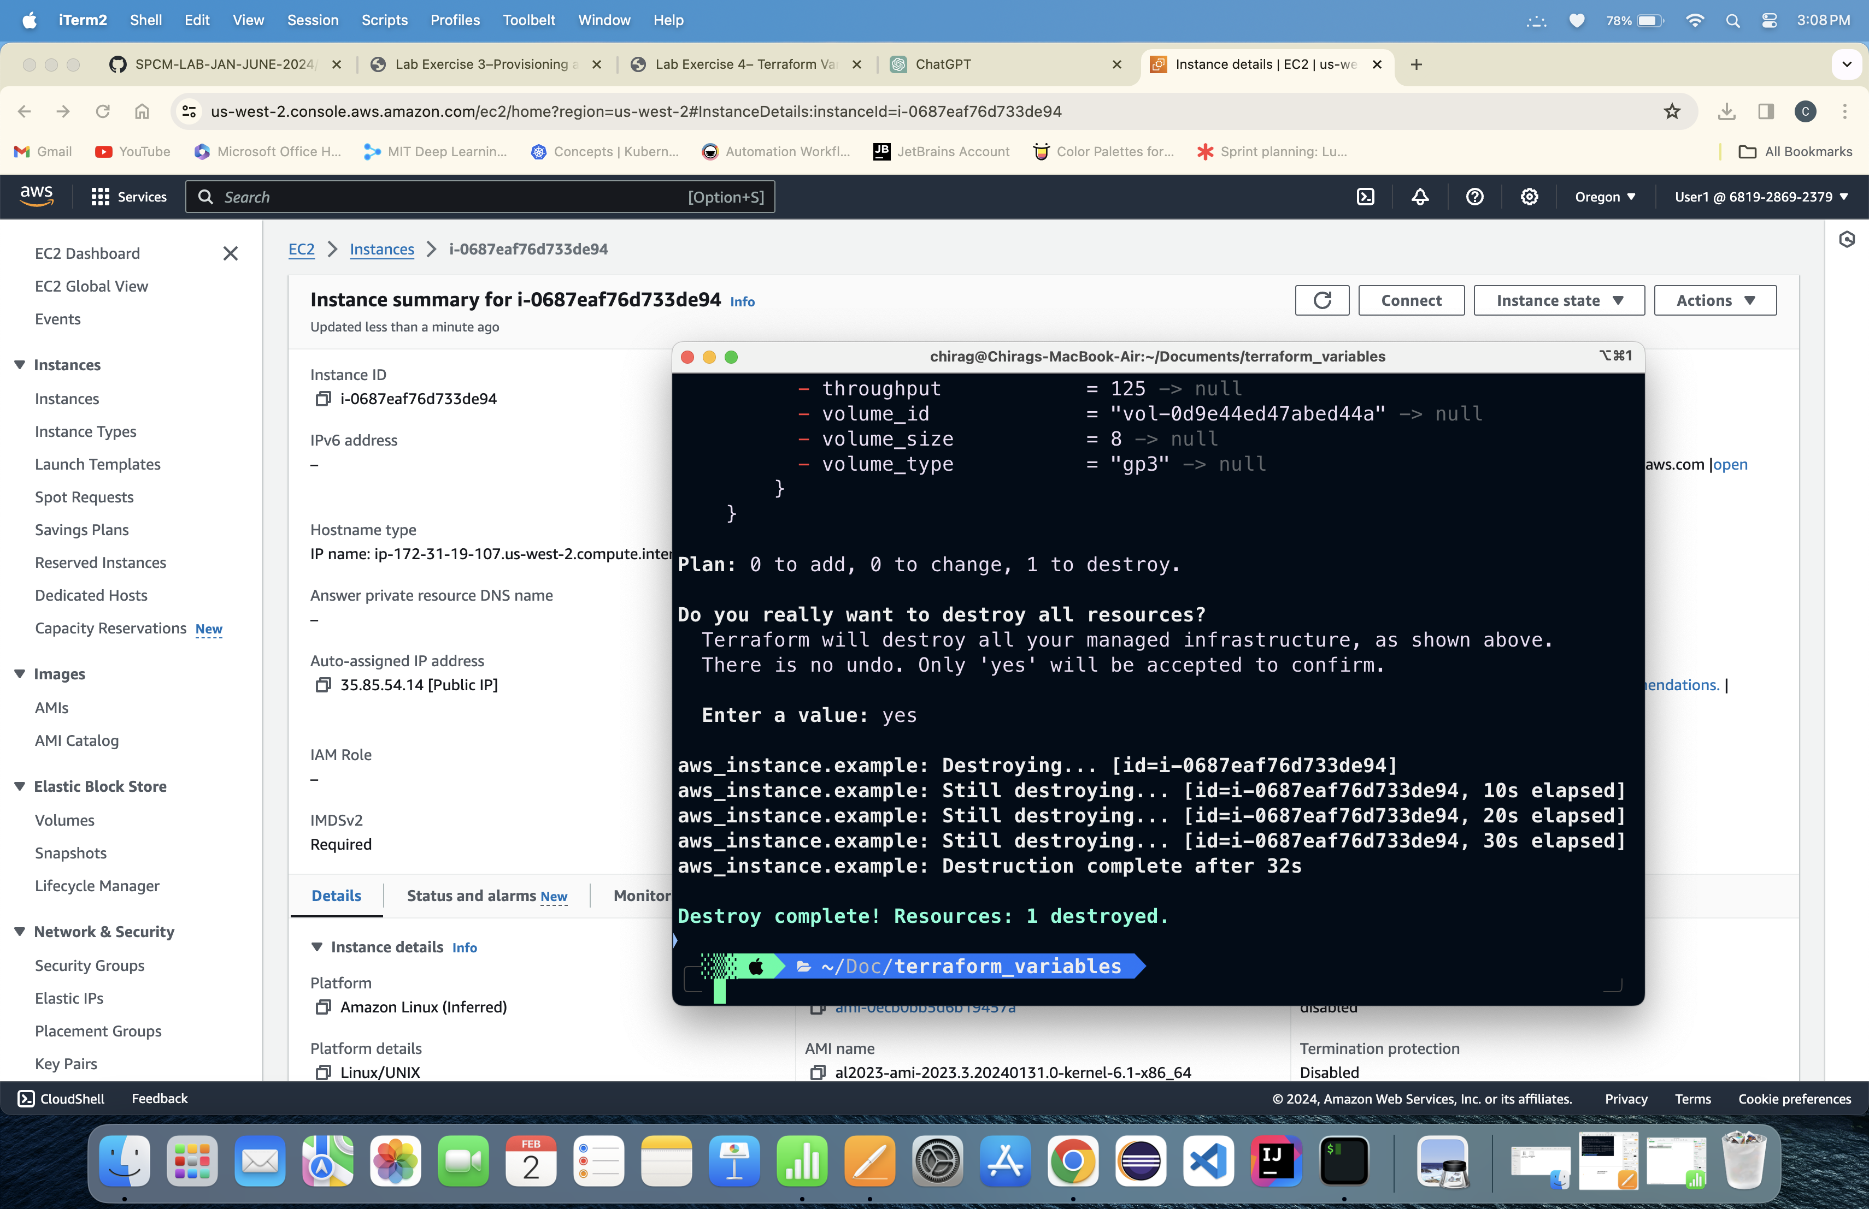estroy command:

Lab Exercise 5

Terraform Variables with Command Line Arguments

1. Create a Director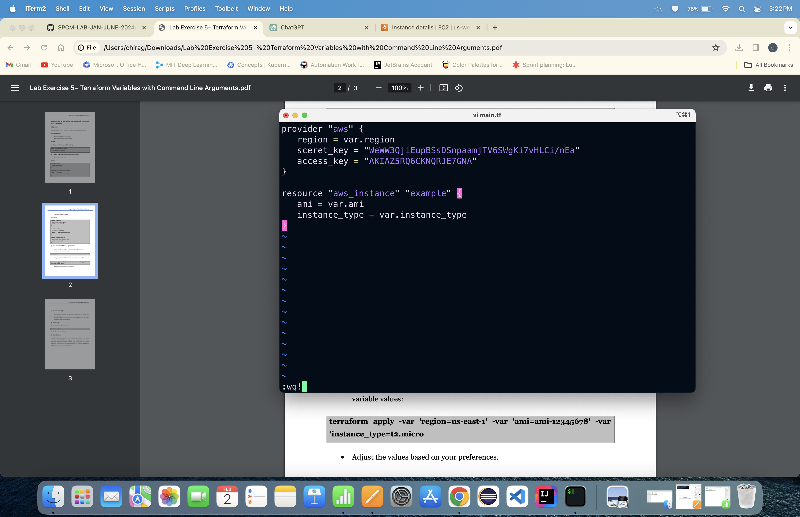y: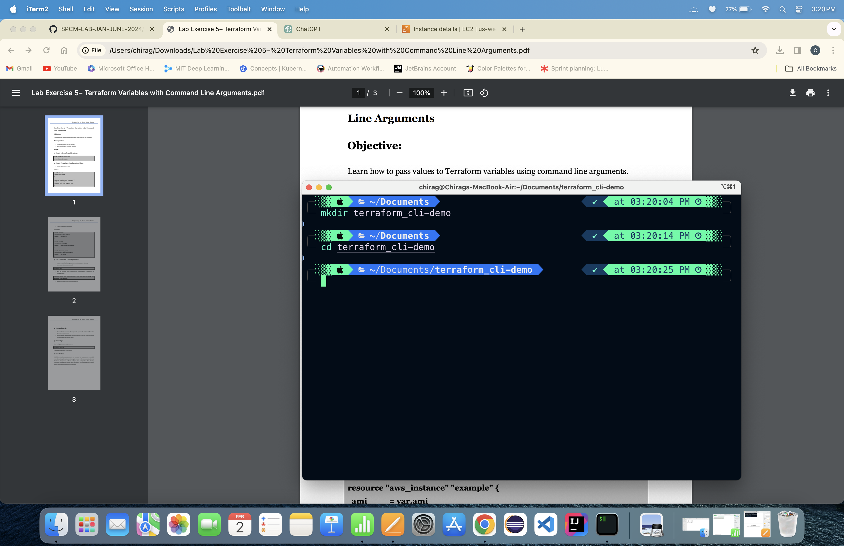

2. Create main.tf file

3. Create variable.tf

4. Running Terraform init command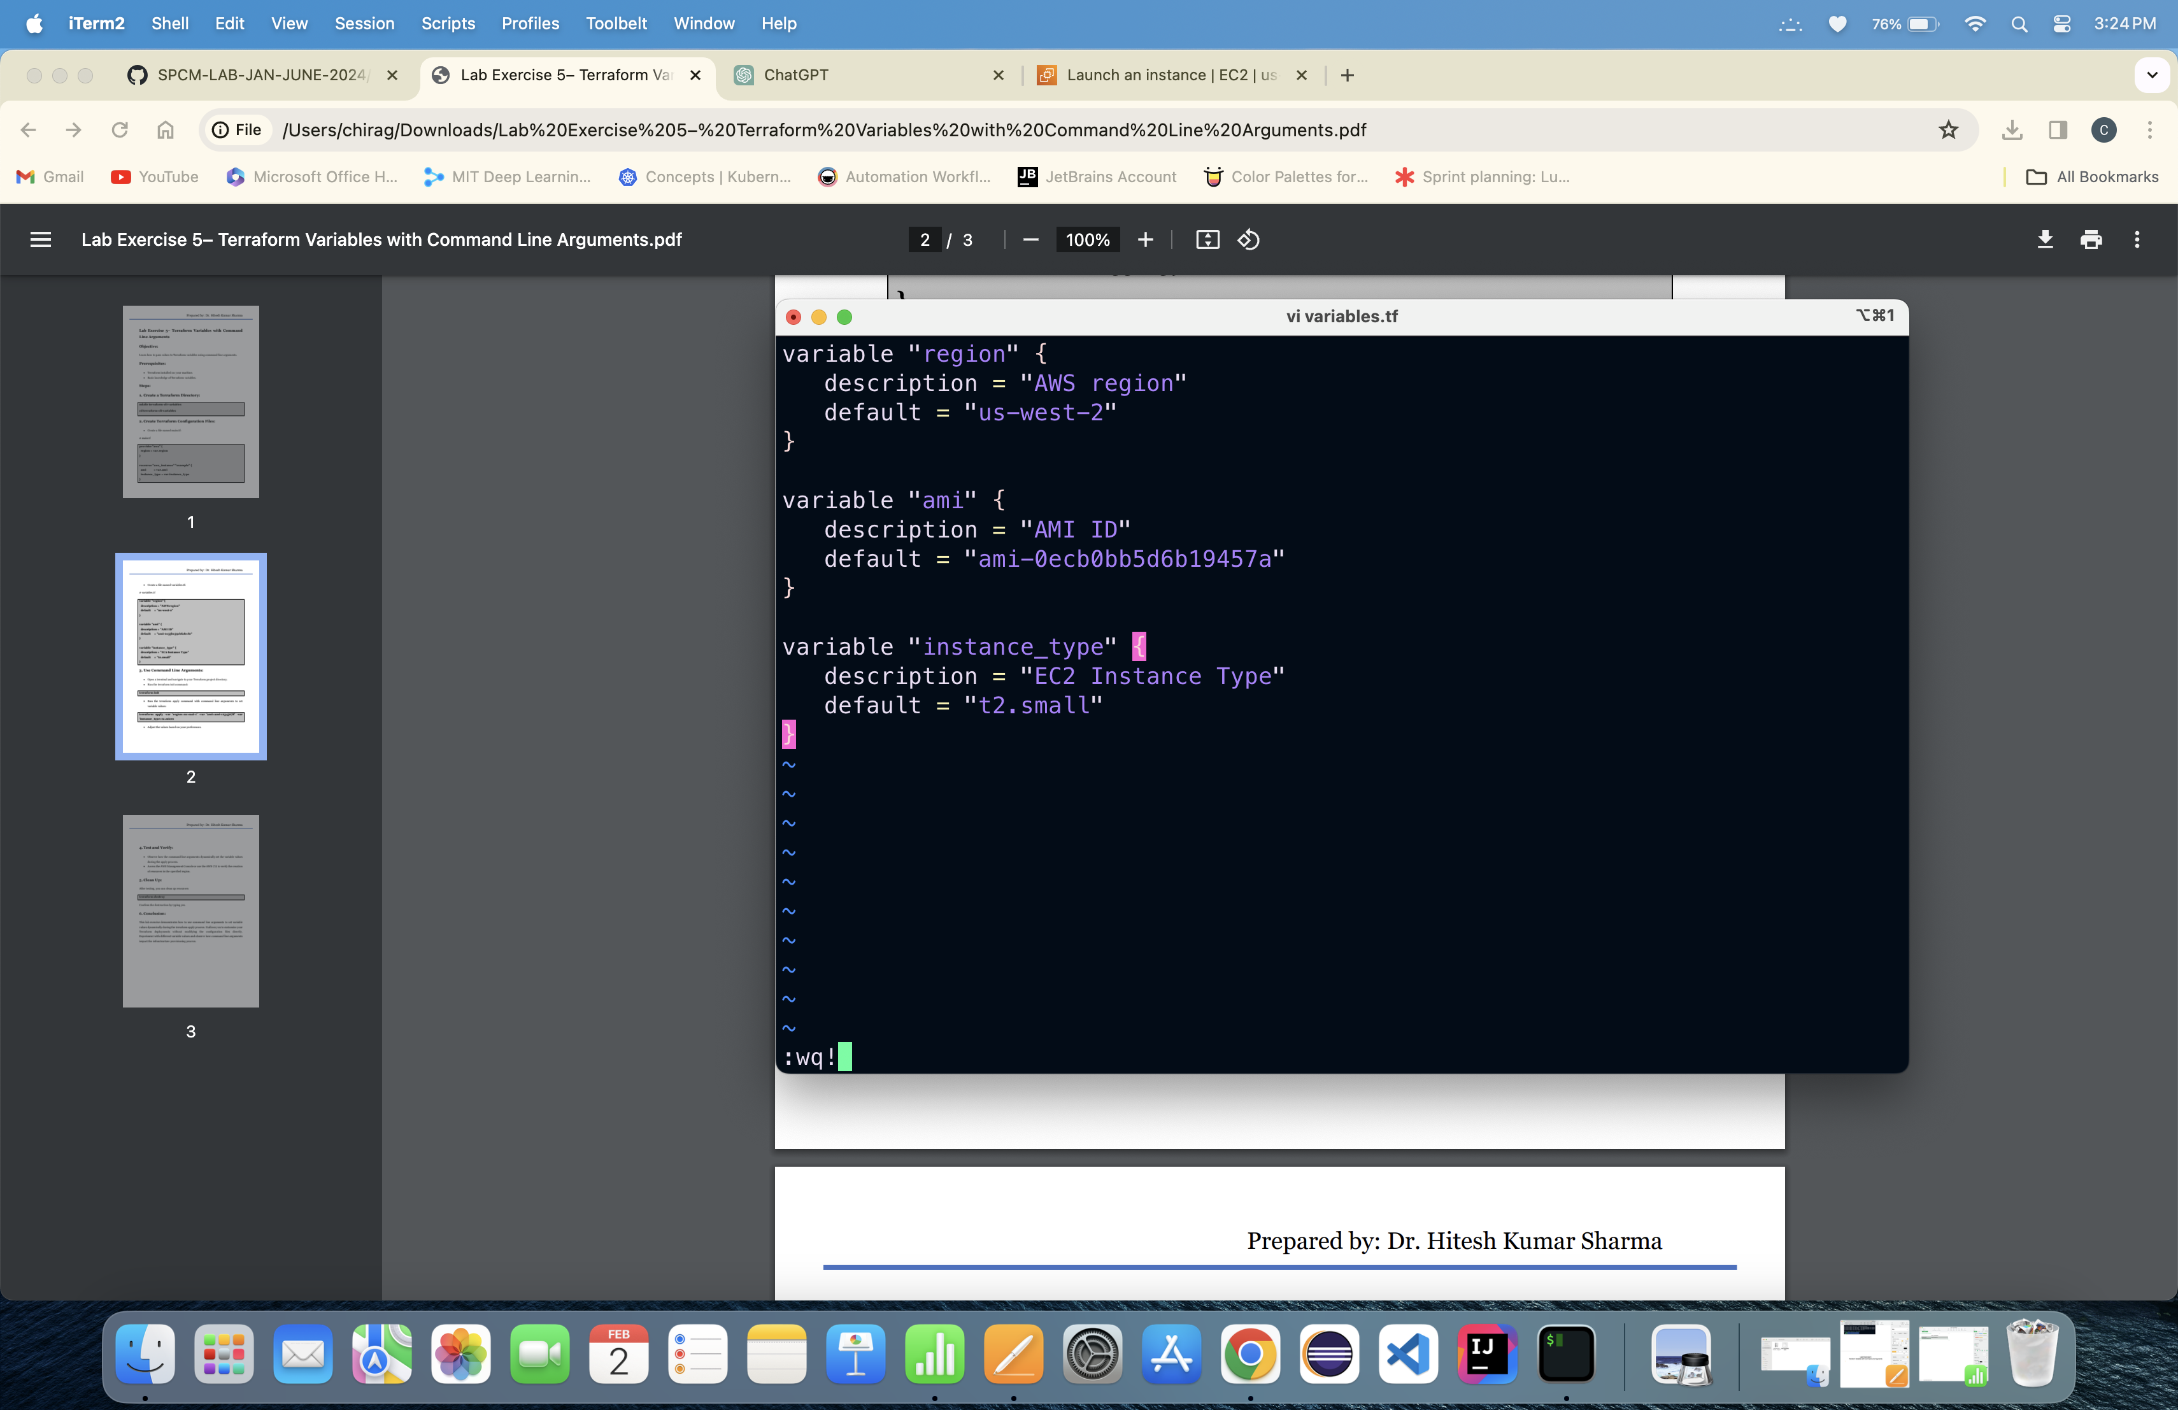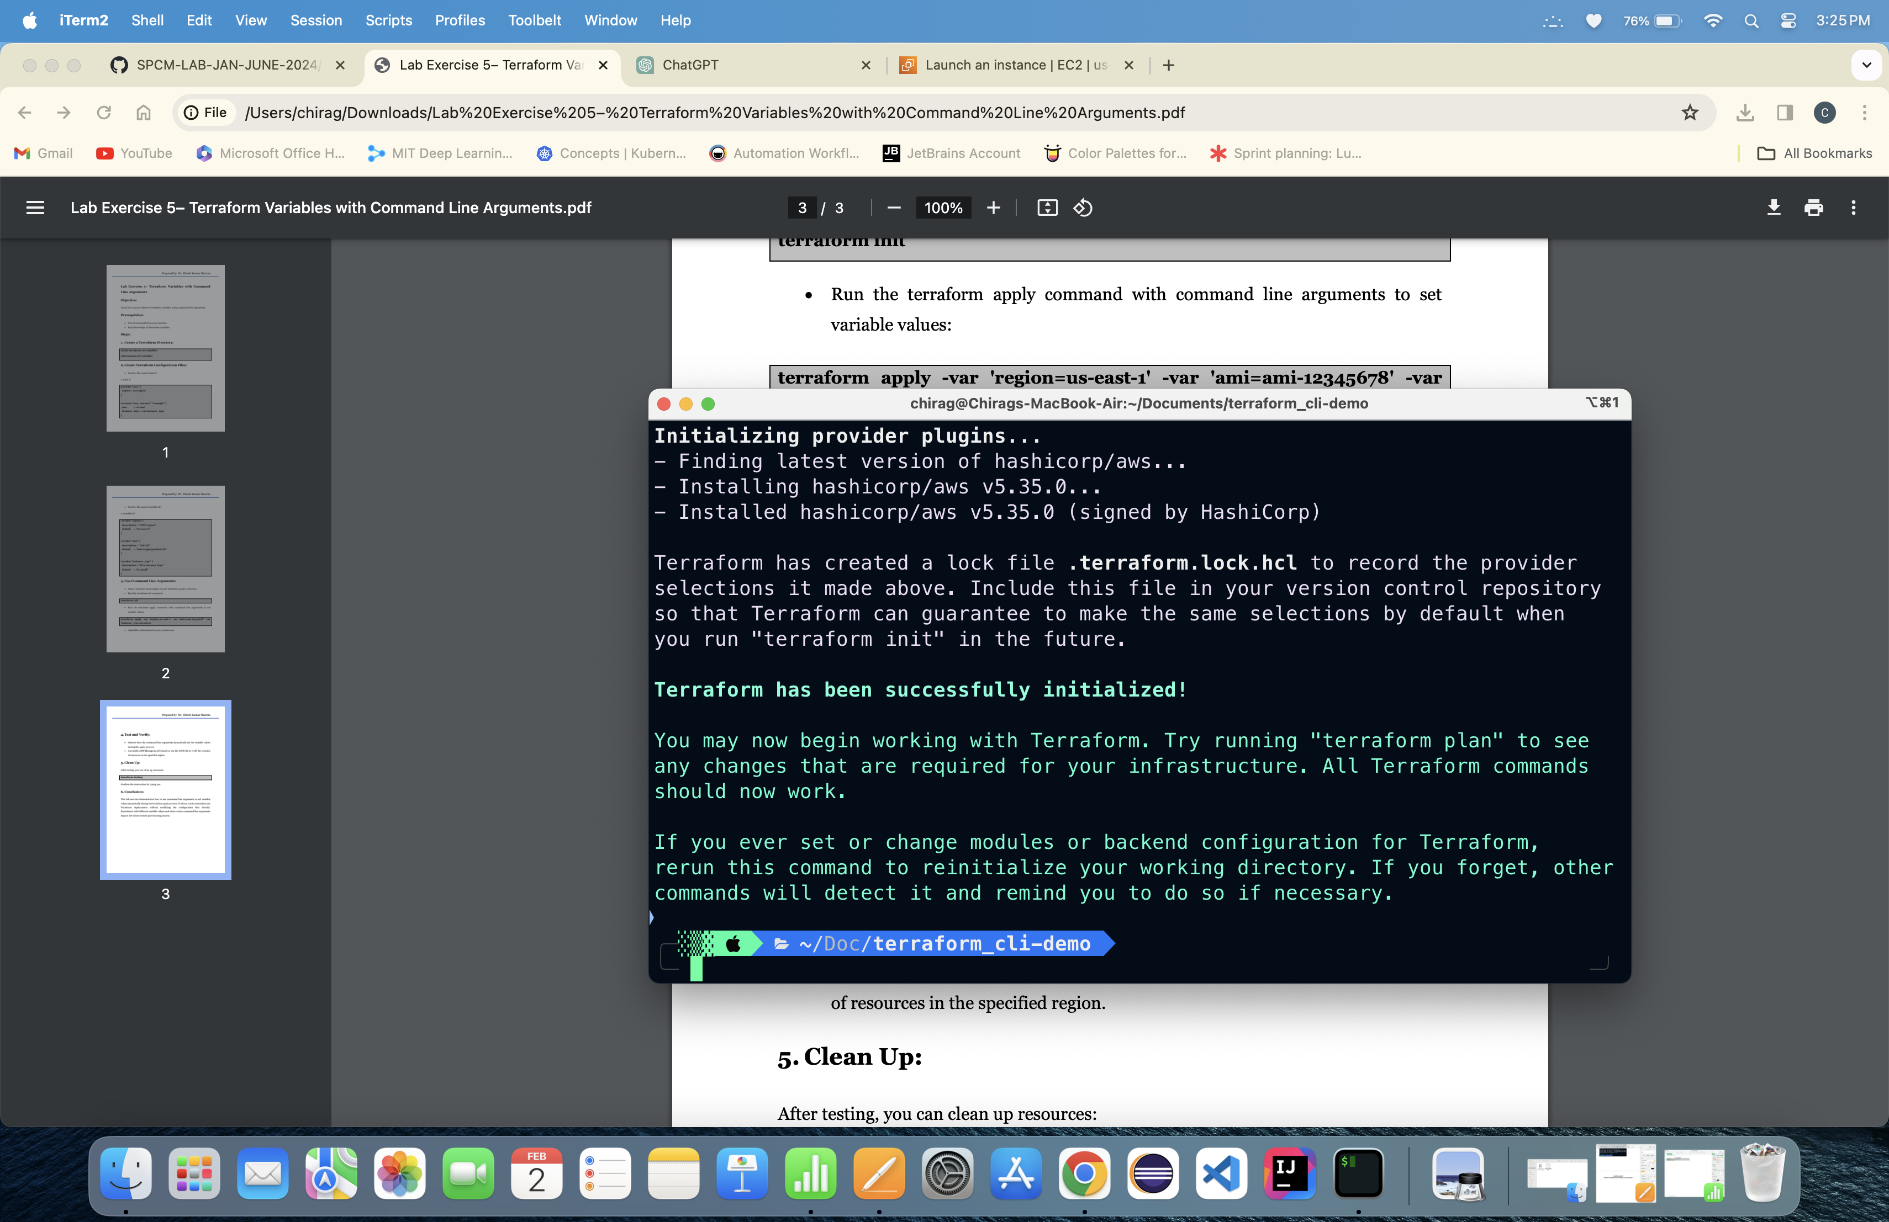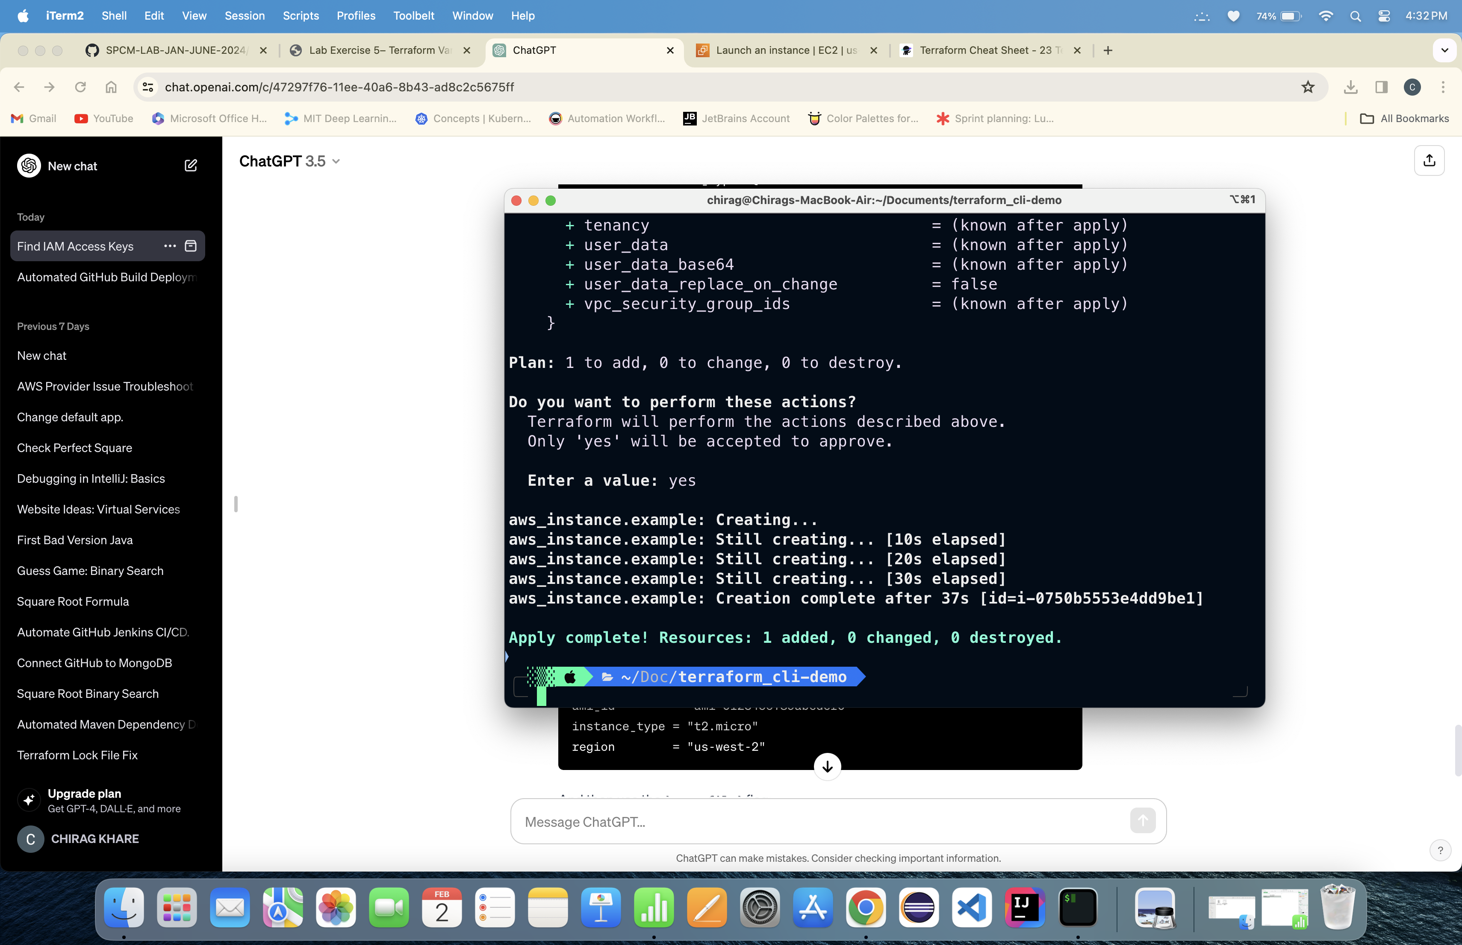

5. Running Terraform Apply command using variable flag:

Instance is created:

6. Running Terrafor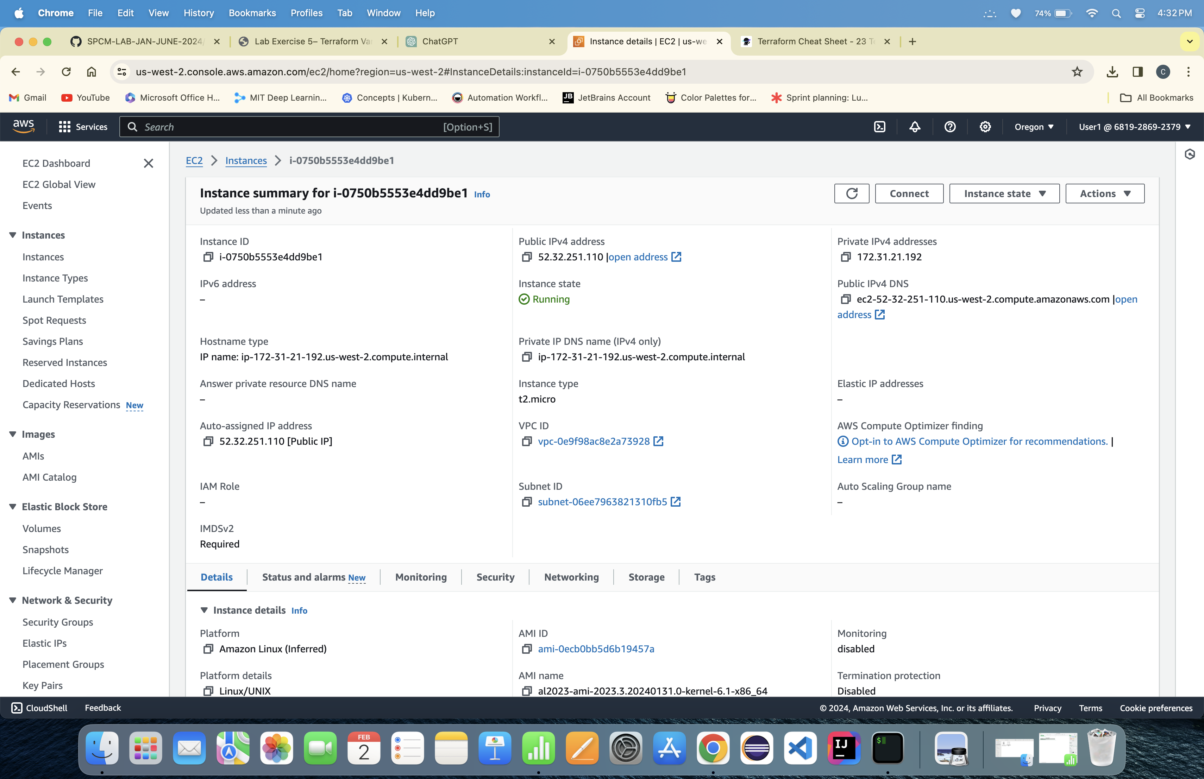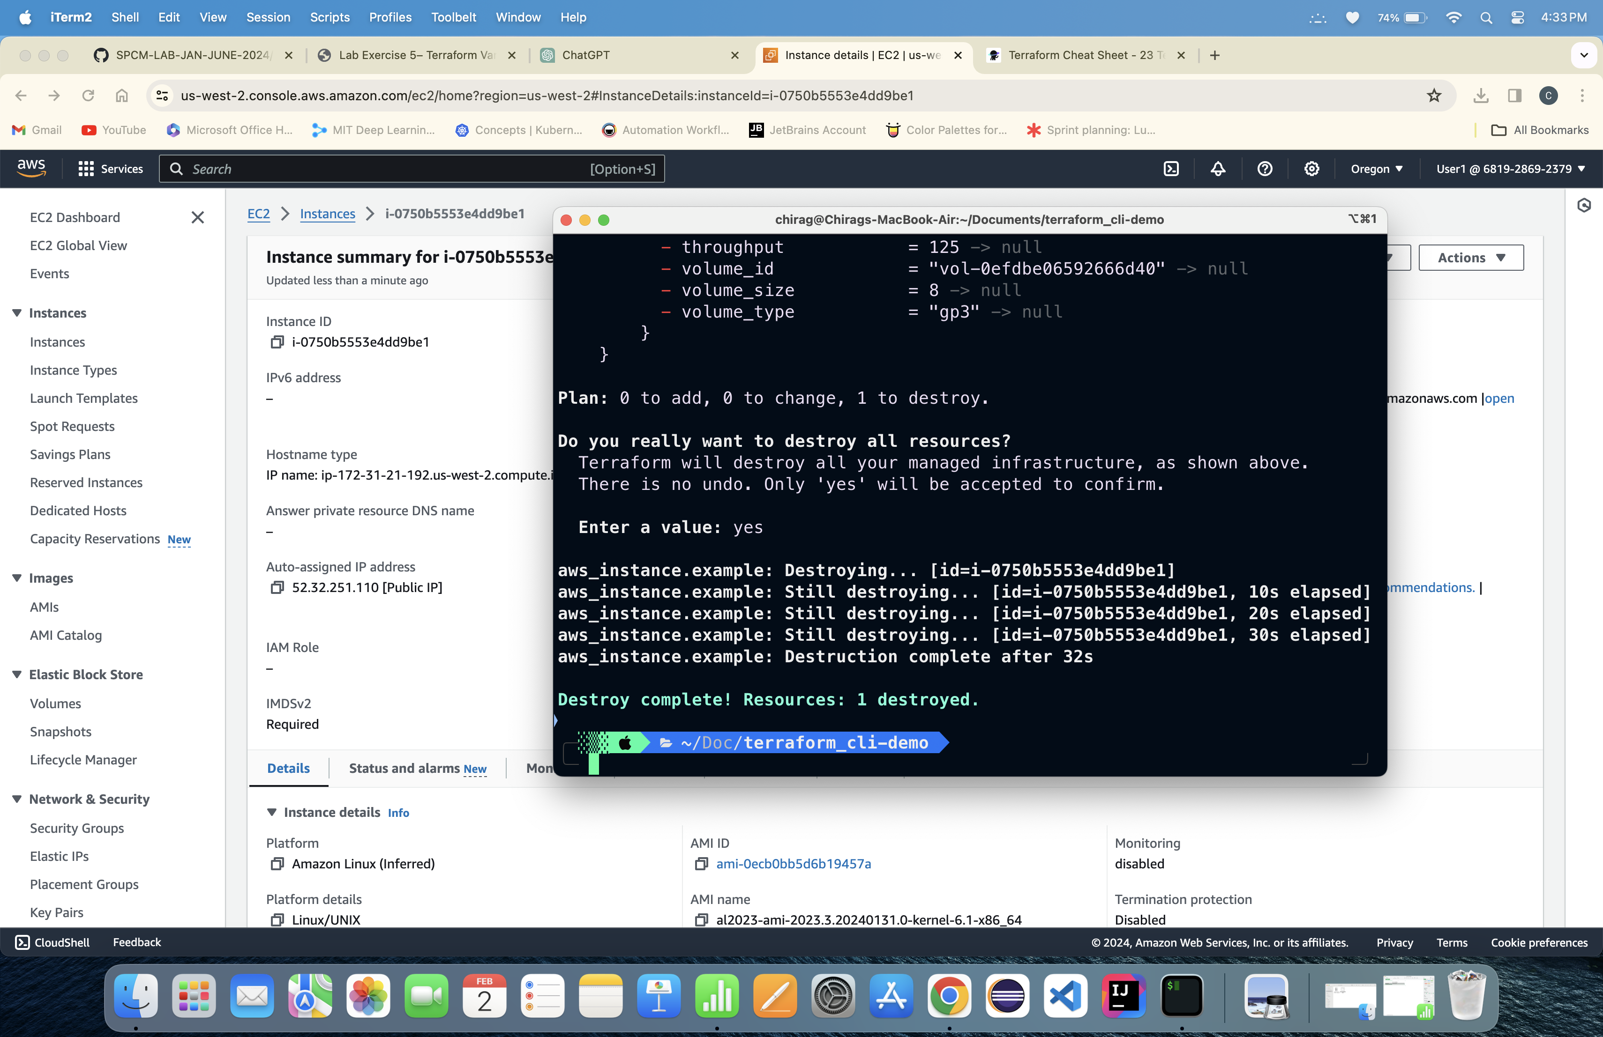m Destroy command:

Lab Exercise 6

Terraform Multiple tfvars Files

1. Create a Terraform Direct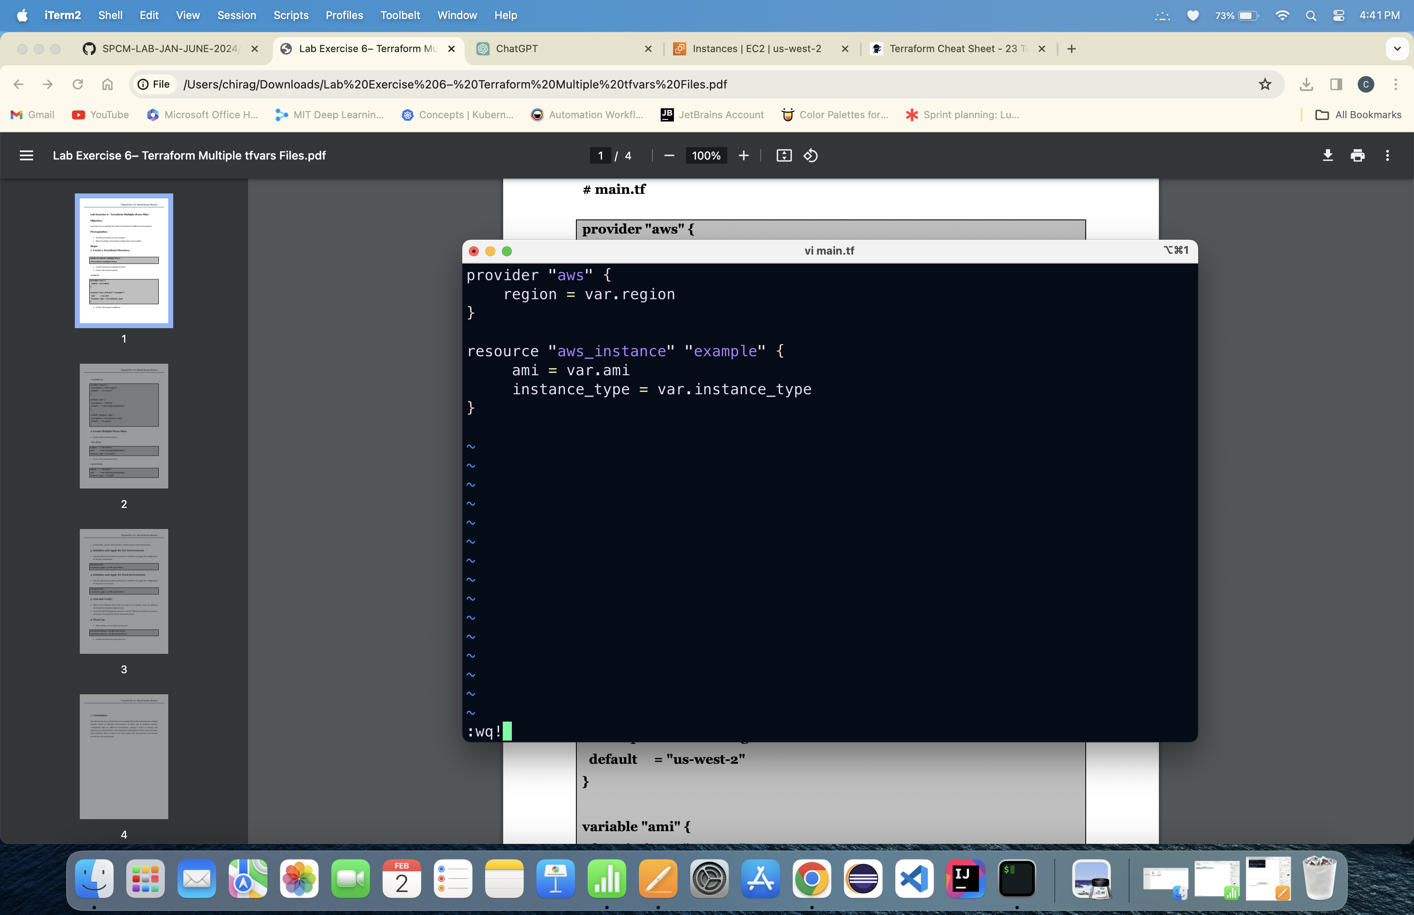ory: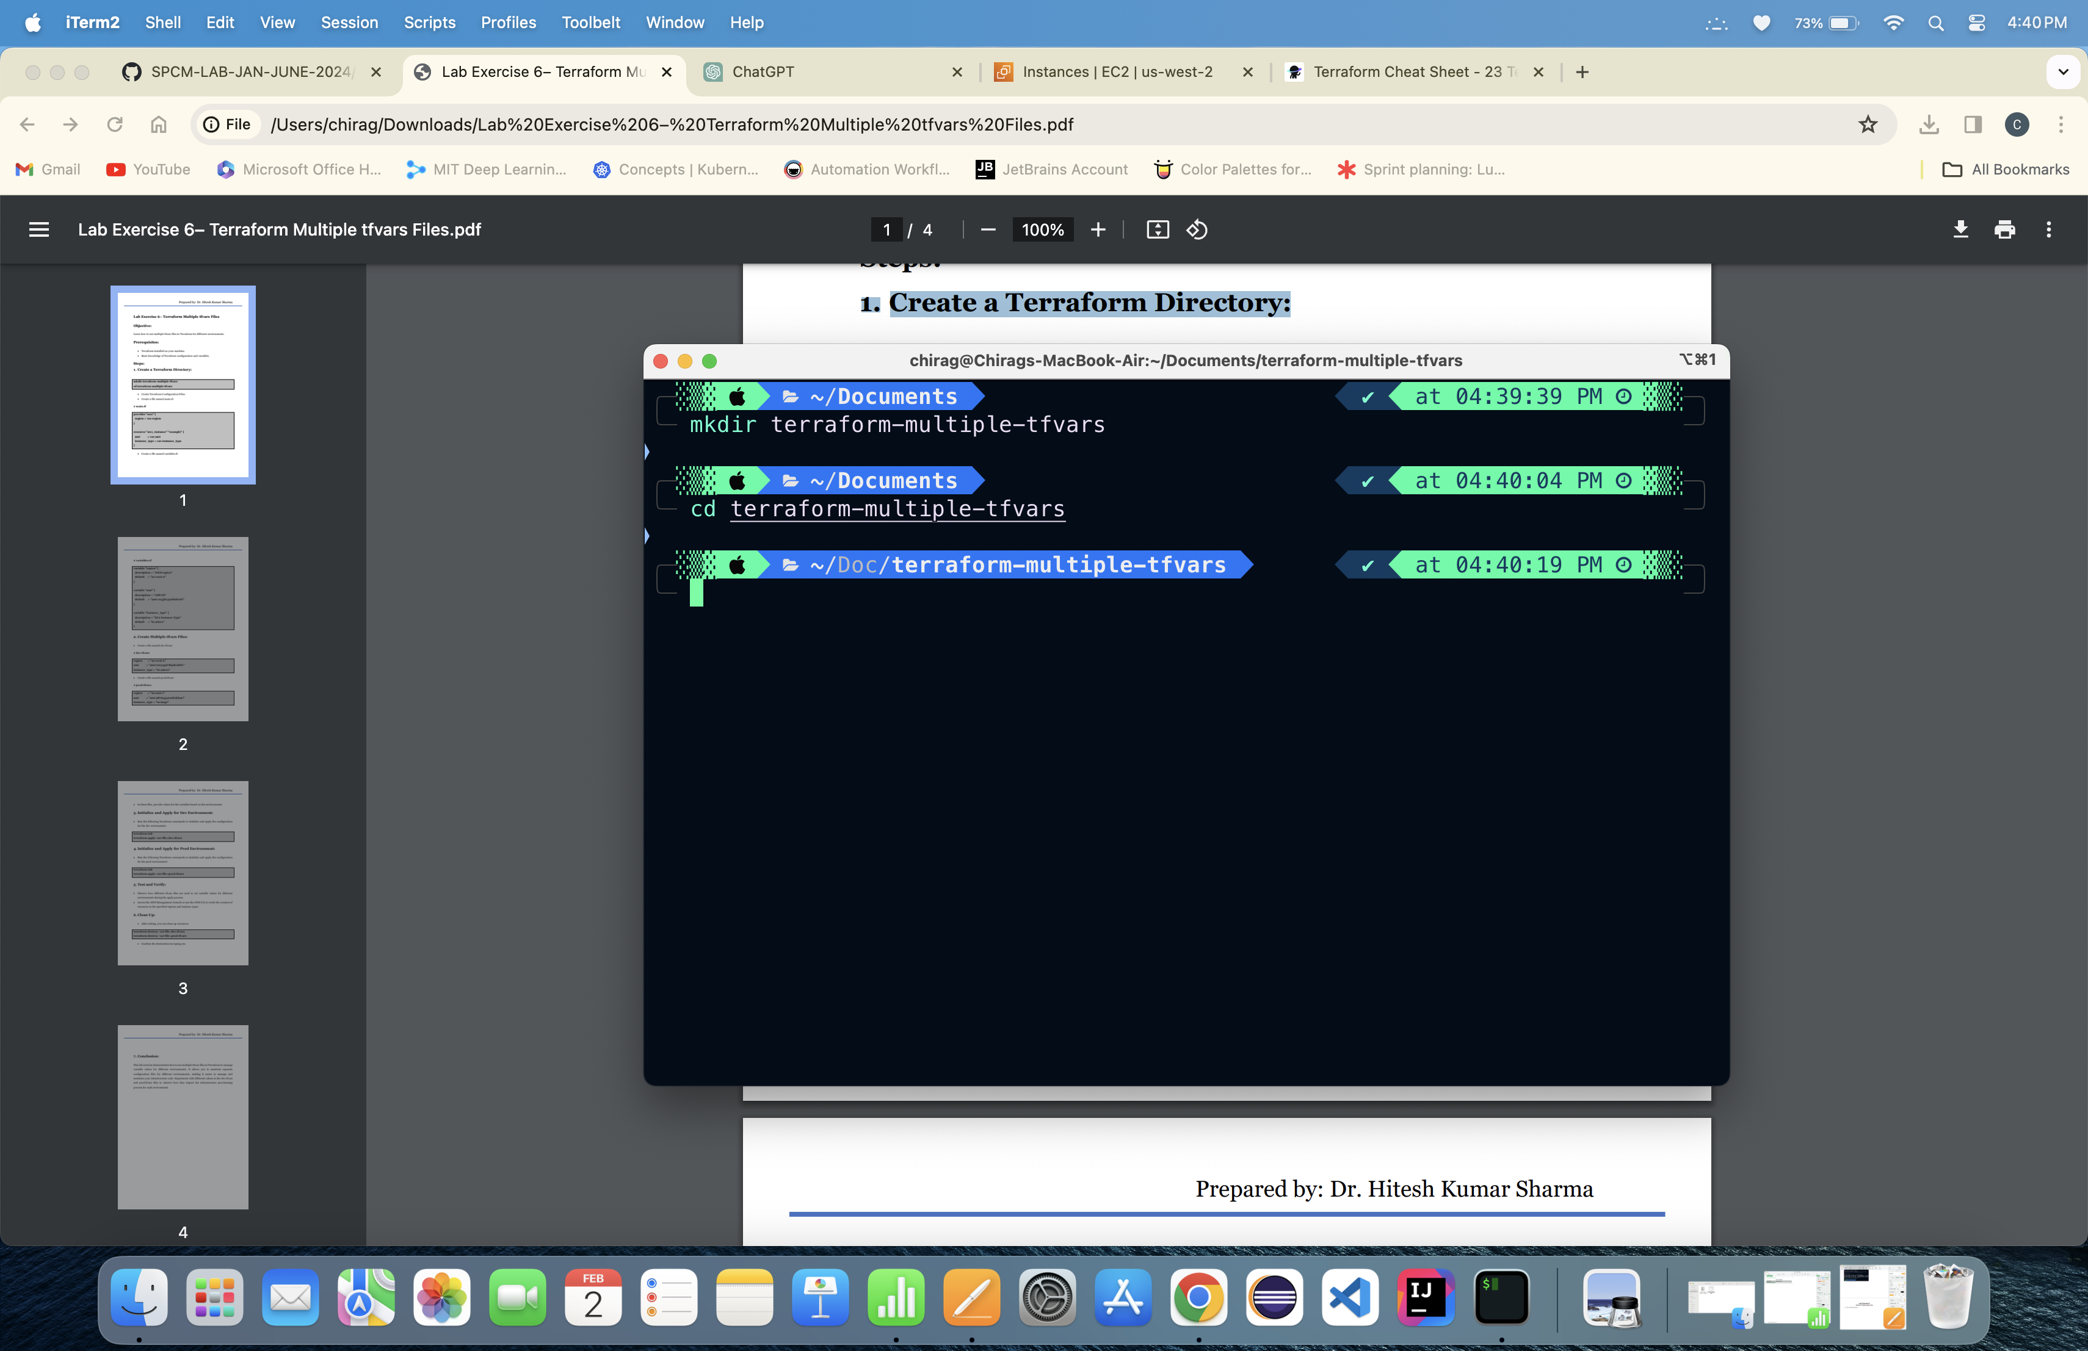

2. Creating main.tf file and variables.tf file:

3. Creating multiple tfvars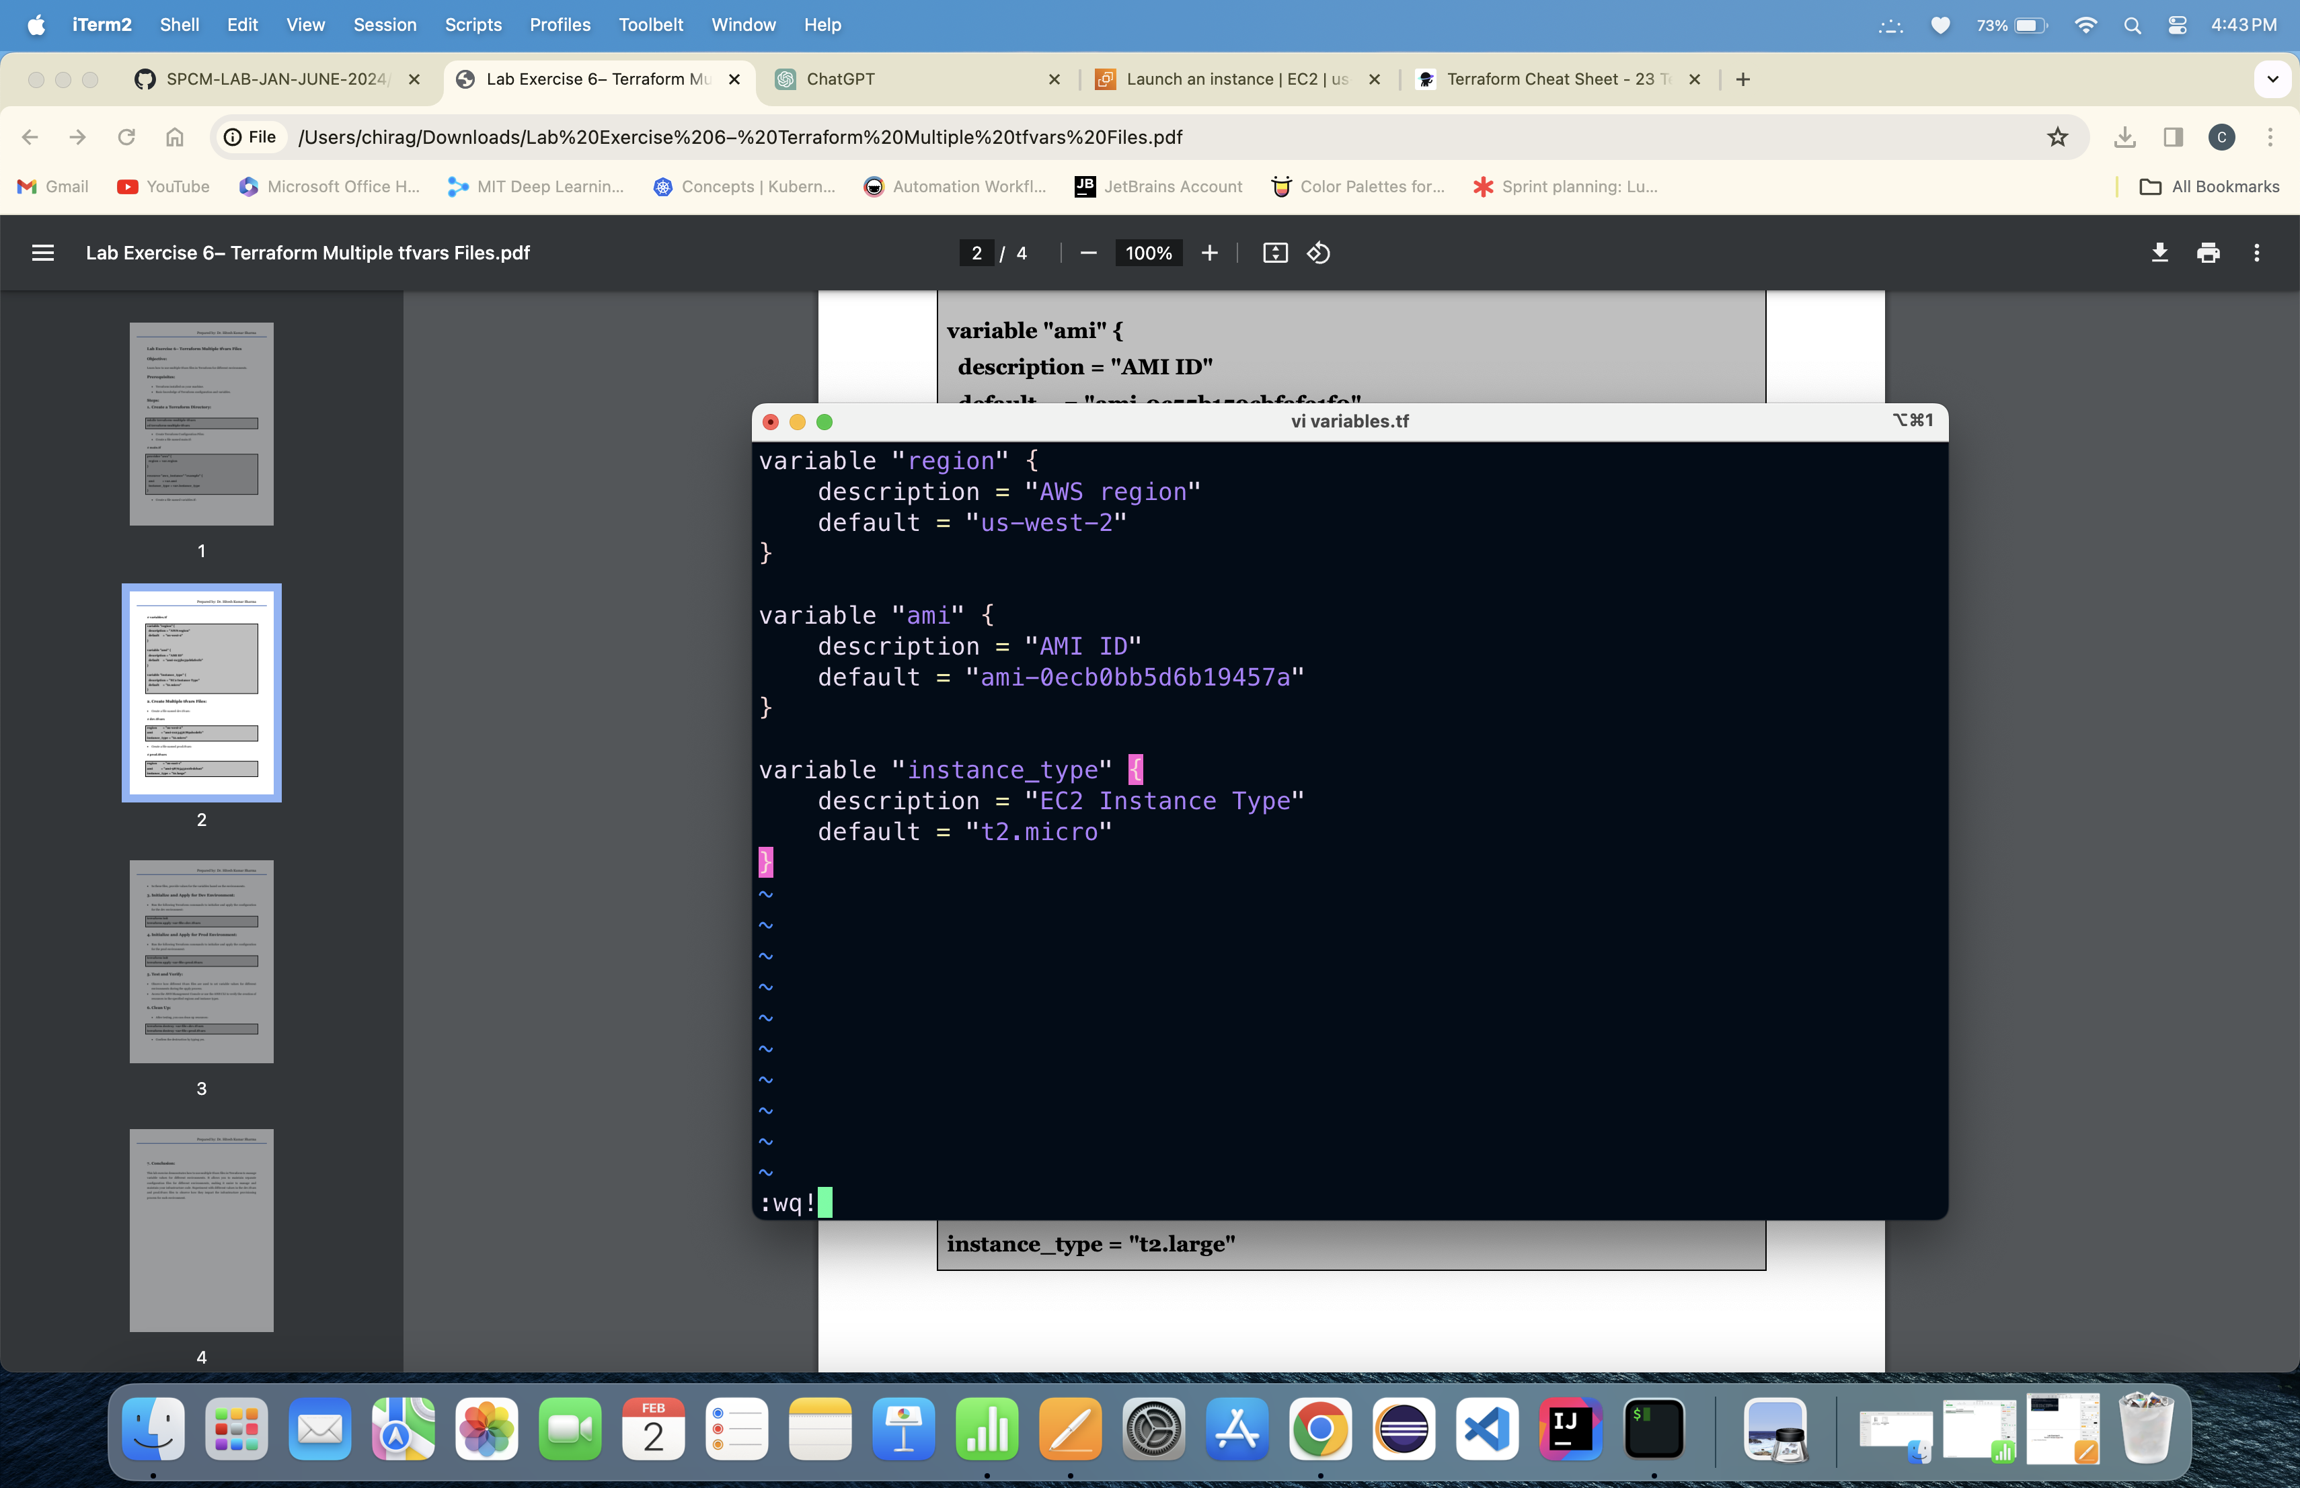 files:

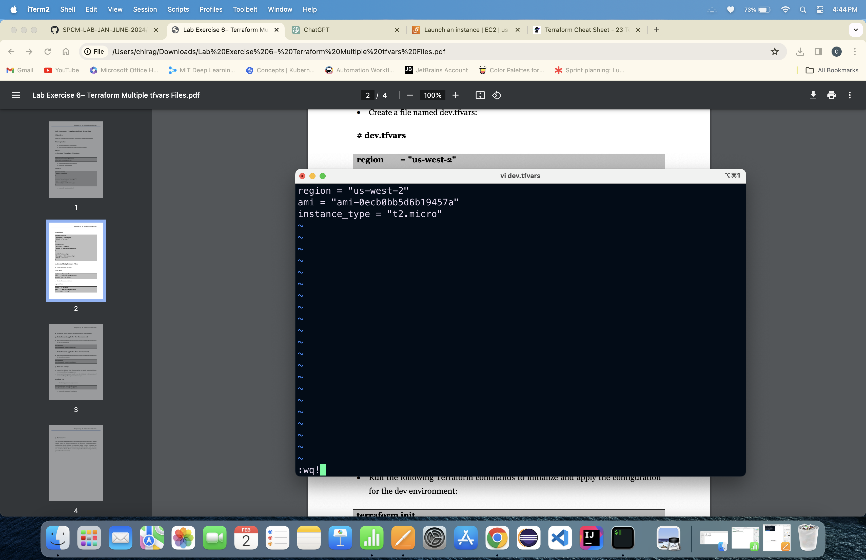

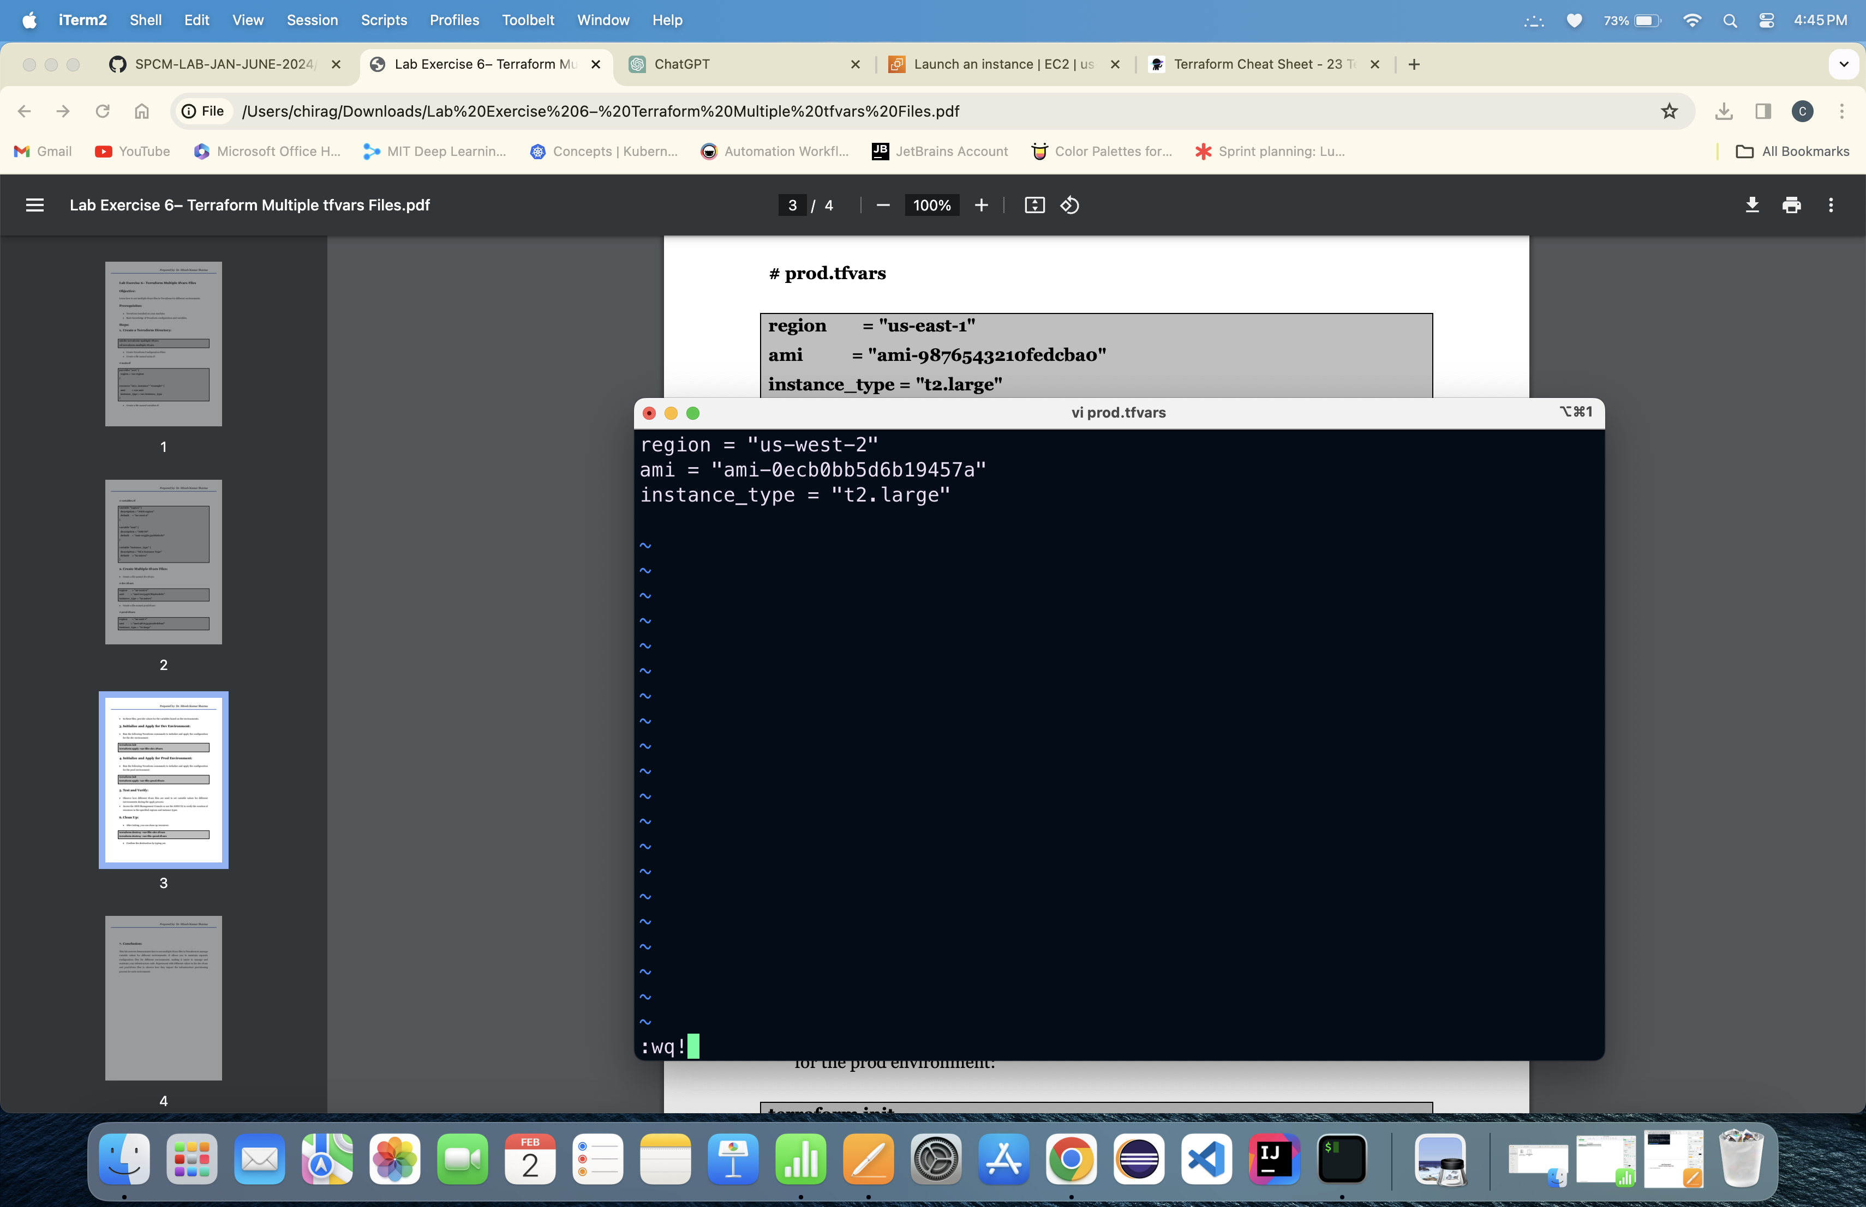

4. Running Terraform init command:

5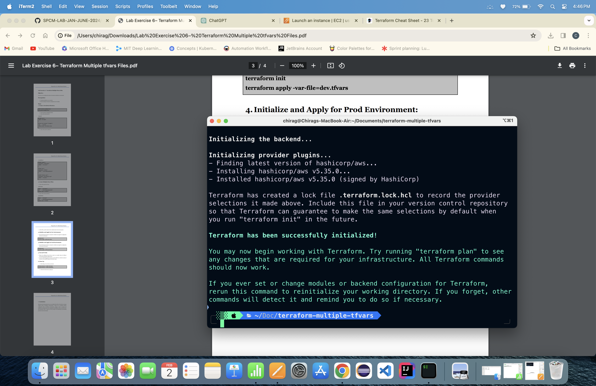. Running Terraform apply command using variable flag:

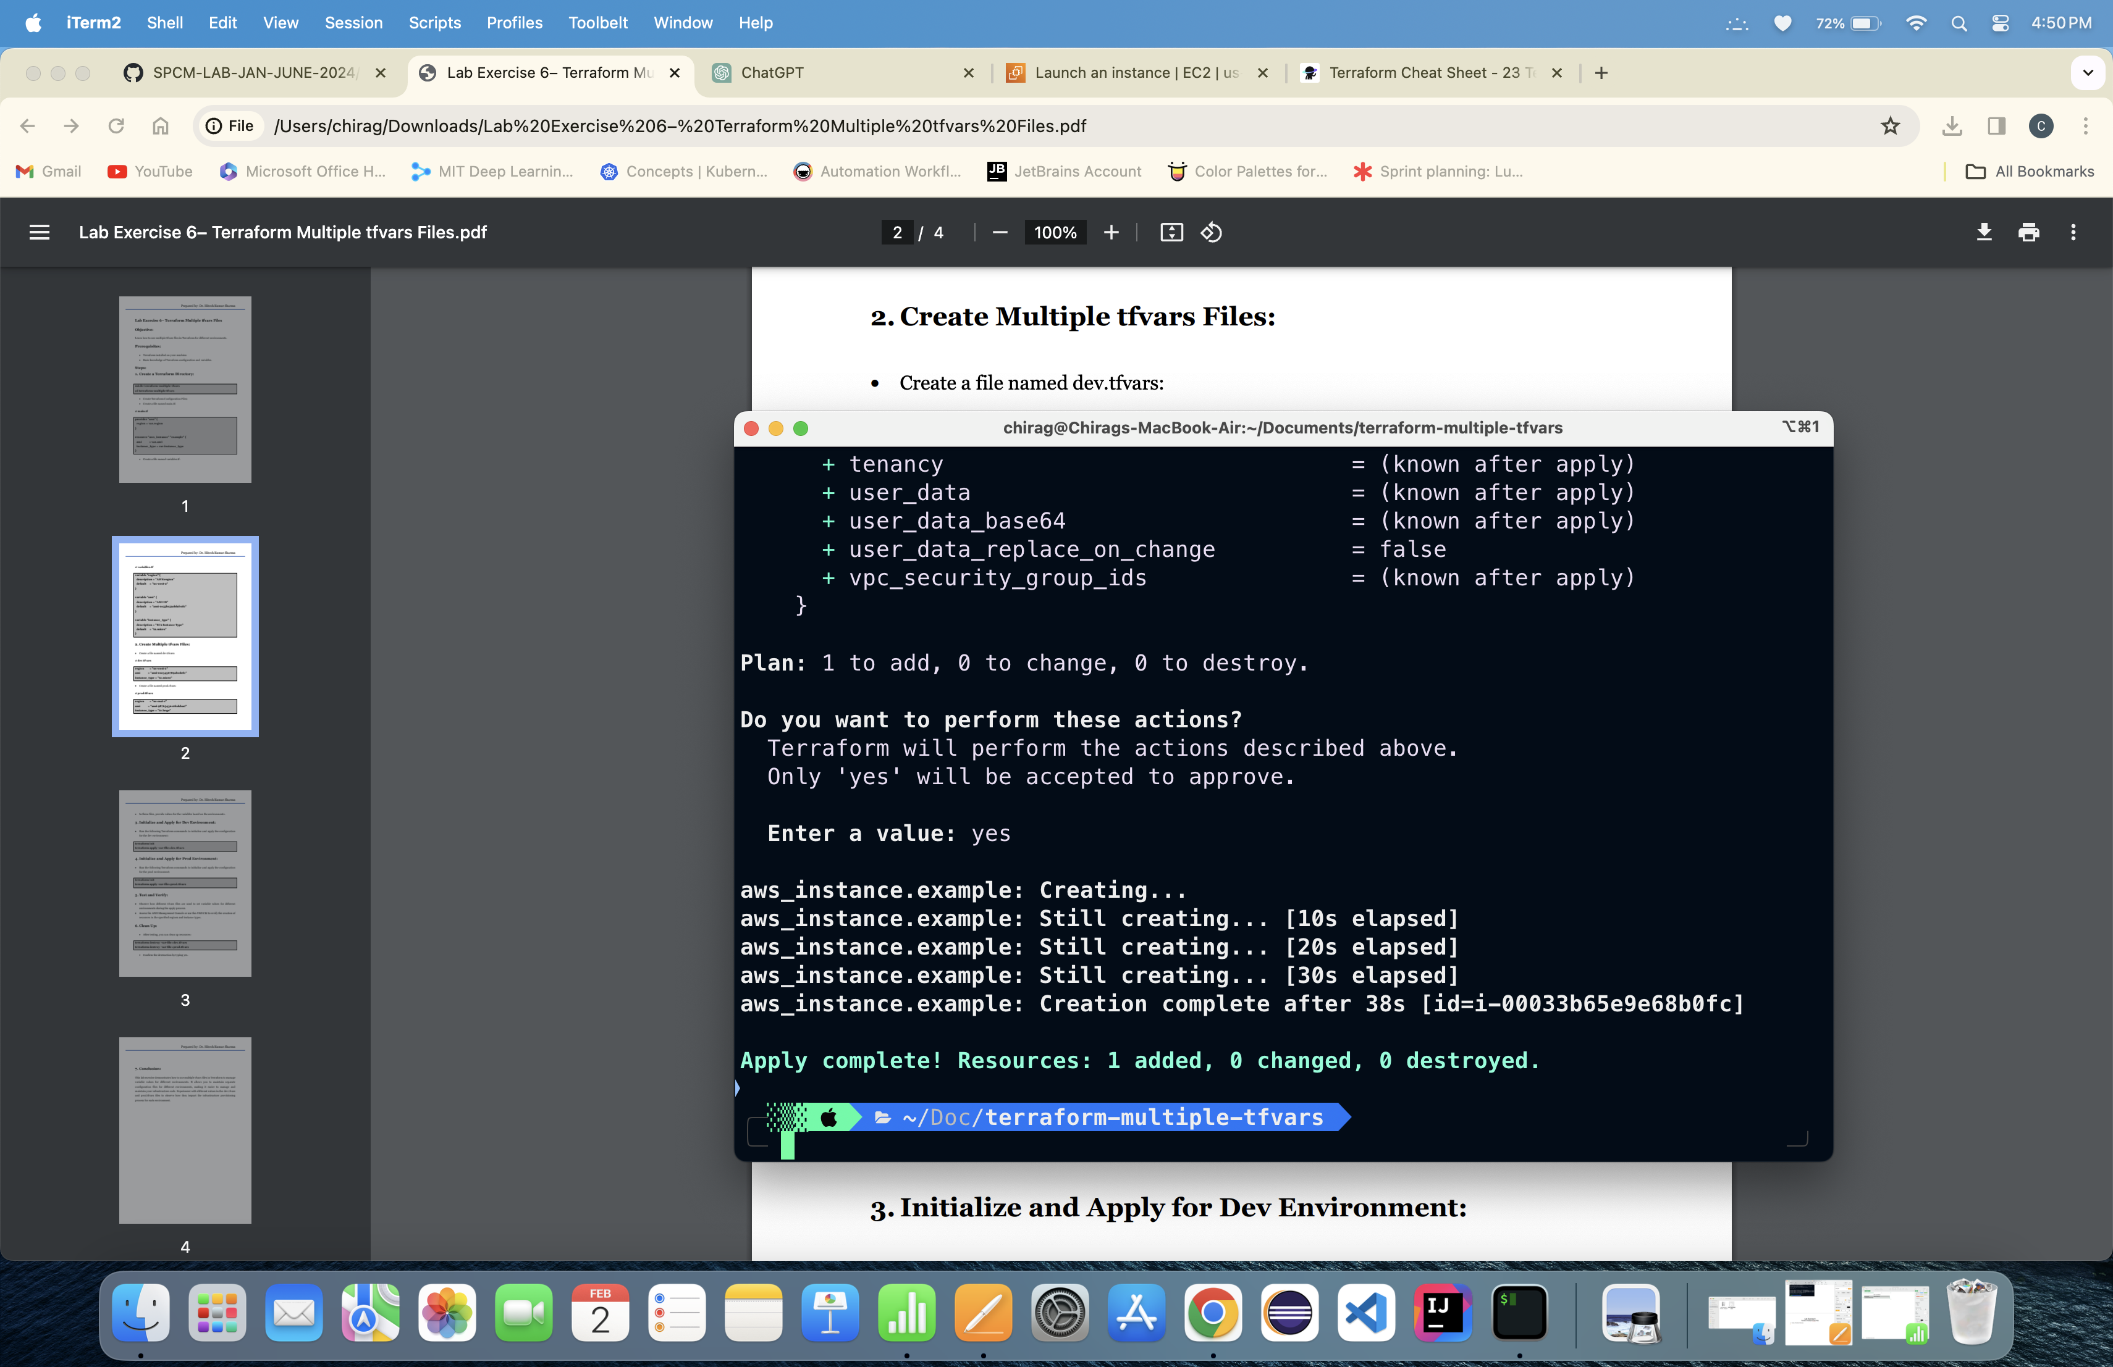

Instance is Created:

6. Running Terraform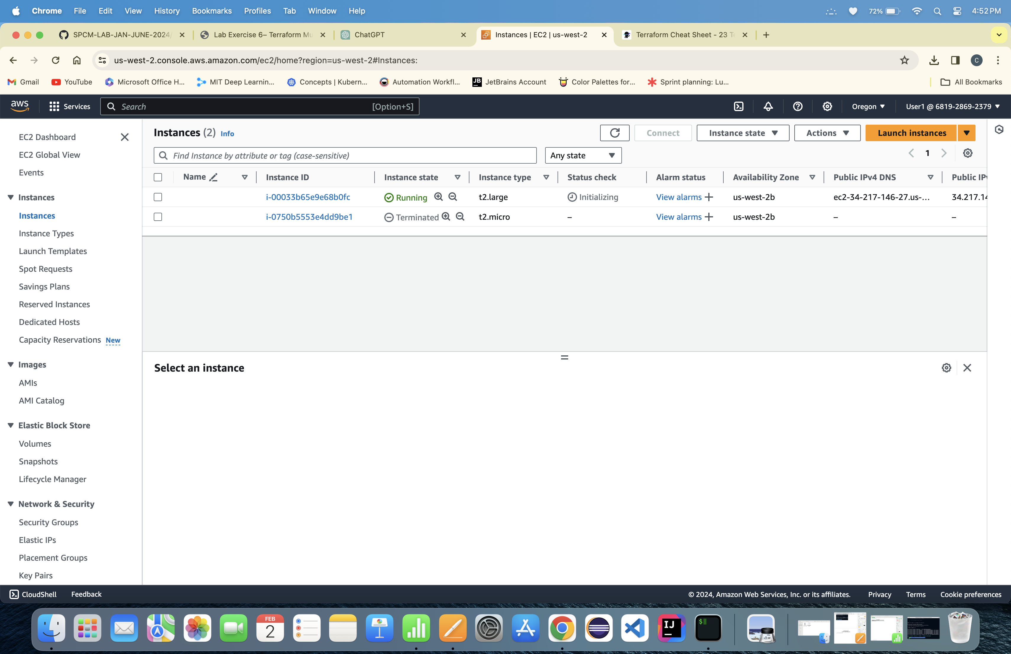 Destroy command:

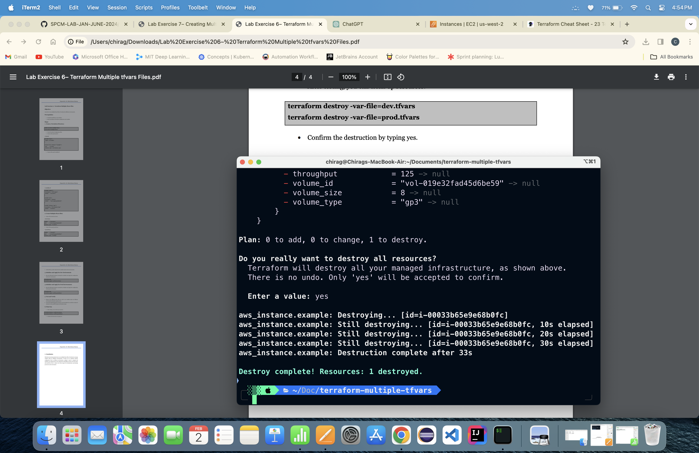

Lab Exercise 7

Creating Multiple IAM Users in Terraform

1. Create a Directory:

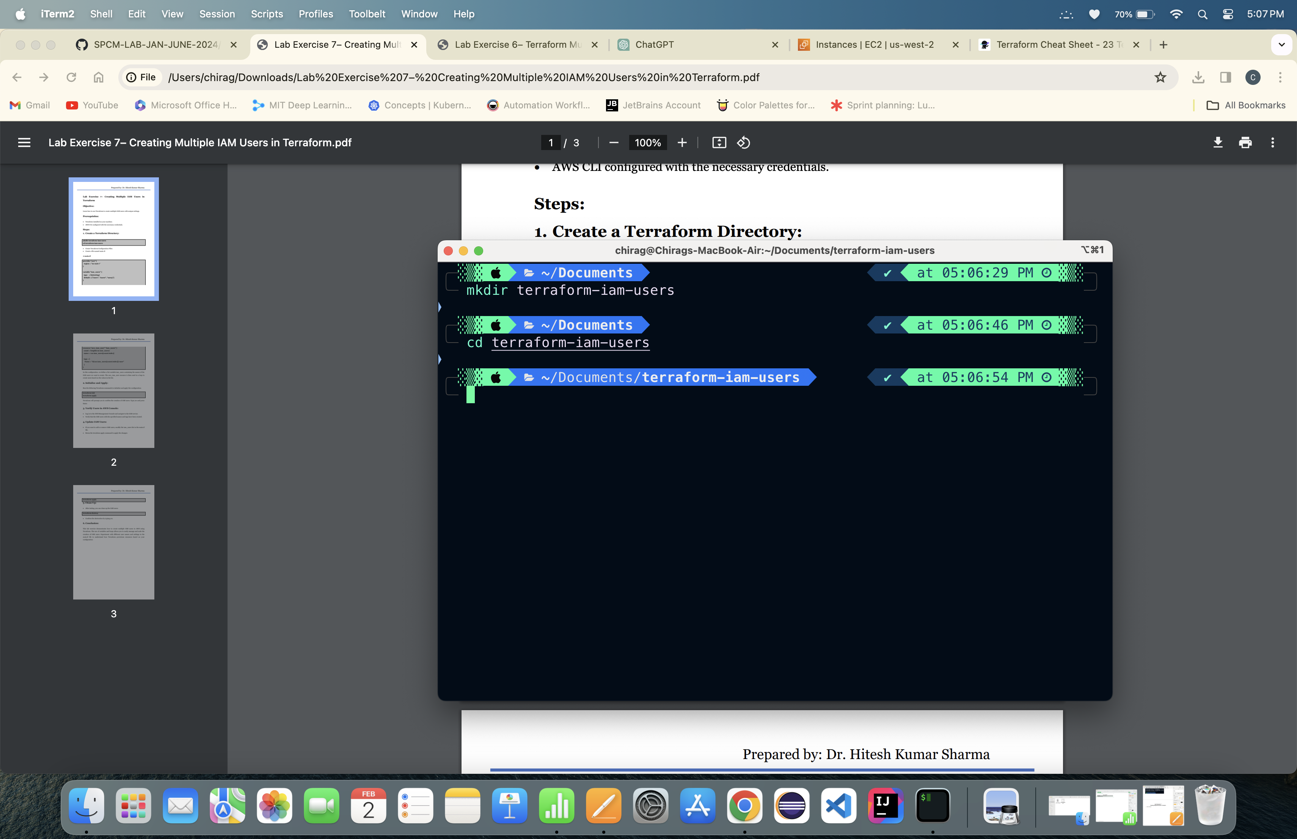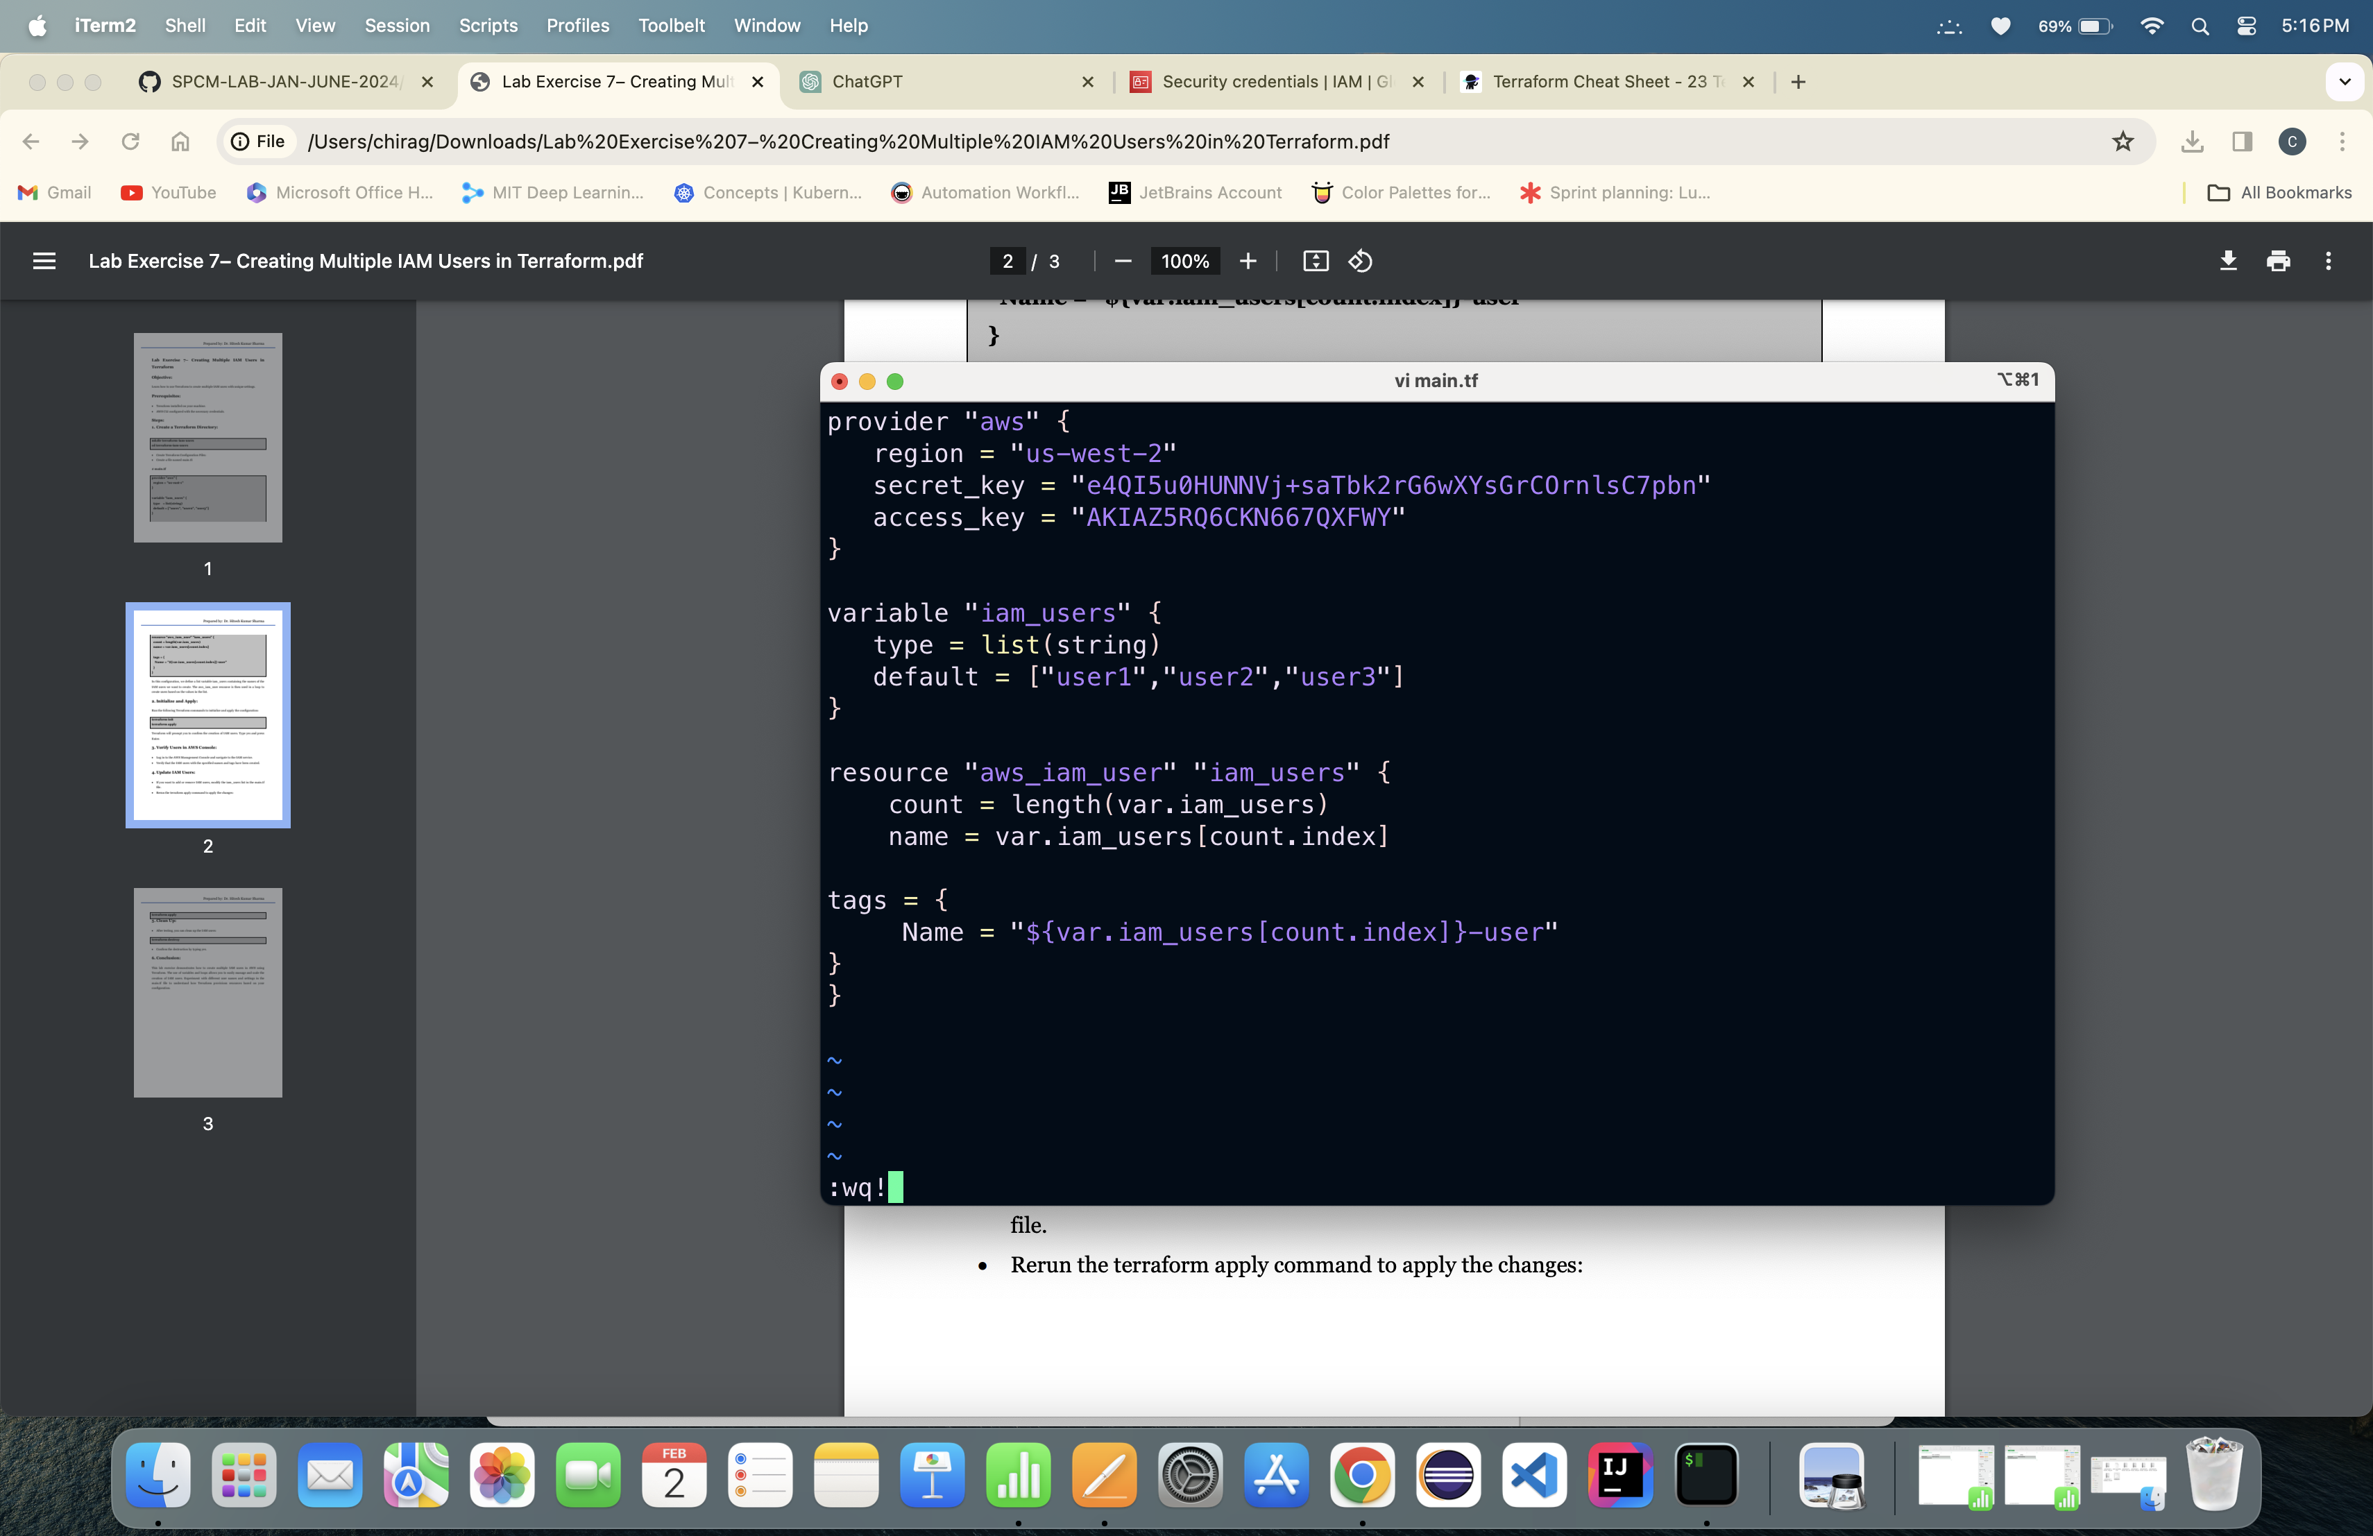

2. Creating a main.tf file

3. Running Terraform init command:

4. Runn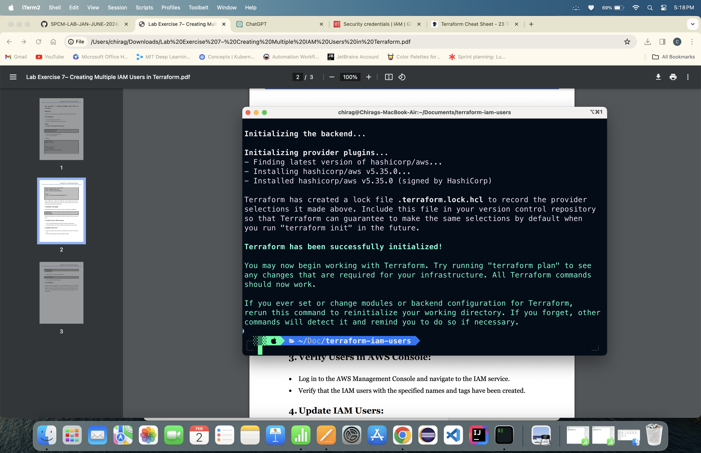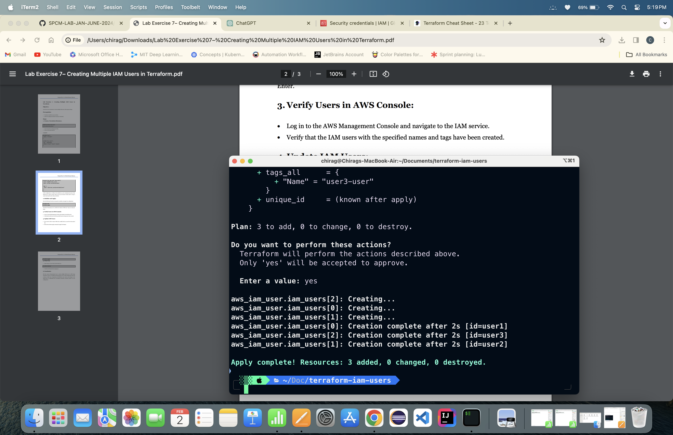ing Terraform apply command:

Users are created:

5. Runni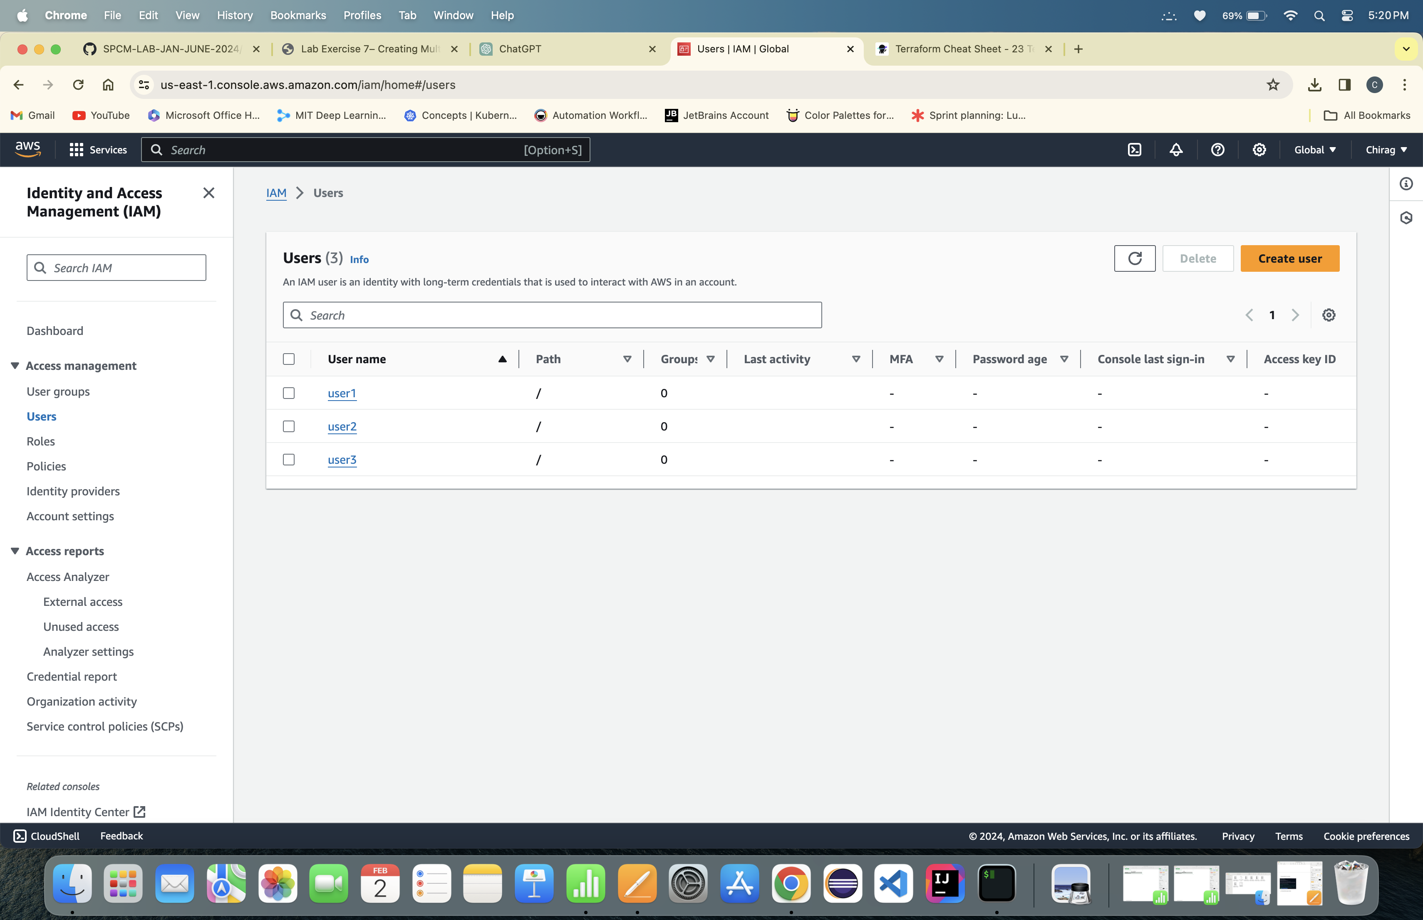ng Terraform destroy command:

